

Kearney School District   
Emergency Communications Plan

Director of Communications and Community Relations Ray Weikal

[weikalr@ksdr1.net](mailto:weikalr@ksdr1.net)

(816) 628-4112

# Table of Contents

**Table of Contents 2**

**Overview 5**

Guiding Principles for Communications and Community Relations in Kearney School District: 5

**Incident Command System - Communications 8**

The Roll of Communications During an Emergency 8

Incident Commander 8

Command Staff 8

Information Sources for Communication of Potential Emergency Situations (Before, During and After) 9

News Media - Designated Emergency Contact List 9

Communications Roles & Responsibilities 10

Before Emergency 10

During Emergency 11

After Emergency 11

Specific Incidents 11

Evacuation 11

Reverse Evacuation 11

Lockdown 12

Lockout 12

Shelter-in-Place 12

Family Reunification 12

Public Health Emergency 12

**Emergency Response Guide for Parents/Guardians 13**

**Emergency Preparedness in KSD 16**

**Emergency Communications Priority Checklist 19**

**Emergency Scripts 21**

Active Shooter 21

All Clear 21

Biological/Chemical Spill/Threat (No Exposure) 22

Biological/Chemical Spill/Threat (Exposure) 22

Bomb Threat (No Evacuation) 23

Contaminated Food/Water Supply 23

Bomb Threat (Evacuation) 24

Criminal Threats/Actions (Credible) 25

Criminal Threats/Actions (Not Credible) 25

Cyber Attack/Threat 26

Death - Accidental/Incidental (Suicide/Overdose) 26

Dangerous Animal (No Evacuation) 27

Dangerous Animal (Evacuation) 27

Dysregulated Student 28

Downed Electrical Line 28

Earthquake 28

Explosion 29

Fire 30

Fire Alarm Pulled 30

Food Poisoning 30

Gas Leak 31

Hazardous Materials Incident 31

Health Emergency/Communicable Disease (Not contagious) 32

Intruder 32

Law Enforcement Emergency (Off-Campus) 33

Lockdown 33

Lock & Teach 34

Medical Response 34

Power Failure (Remain On-Site) 35

Pandemic - Health Emergency/Communicable Disease 35

Power Failure (Use Alternate Site) 36

Reunification 37

Shooting (Off Campus) 37

Student Shot (Off Campus) 37

Structural Issue/Failure 38

Snow Day - Parents/Guardians (AM Notification) 38

Snow Day - Parents/Guardians (PM Notification) 39

Snow Day - Staff (AM Notification) 39

Snow Day - Staff (PM Notification) 39

Structural Issue/Failure 40

Transportation Incident (No Injuries) 40

Transportation Incident (Injuries) 41

Tornado Warning 41

Utility Failure 42

Weapon 42

**Holding Statements 43**

**SchoolMessenger Emergency Broadcasts 45**

Set-Up Messages 45

Create Robocall 47

Create Eblast 47

Create Push Notification 49

Send Message 50

**Media Relations During Emergencies 51**

Public Information Officer 51

News Media Guidance: 51

Script for setting up interviews 52

Possible Responses to Requests for Further Information 52

Responses Related to FERPA 53

Public Info Regarding Lockdowns: 53

Spokesperson Responsibilities 53

**Family Educational Rights and Privacy Act (FERPA) Considerations 55**

**Guidelines for Post-Incident Statements 56**

Appropriate Statements Following an Emergency: 56

Inappropriate Statements Following an Emergency: 56

**Cyber Events/Incidents 57**

**After-Incident Debrief 58**

# 

# Overview

For many people, school emergencies now bring to mind thoughts and memories of high-profile incidents at schools across the United States, including shootings at Columbine High School in Littleton, Colo., Sandy Hook Elementary School in Newtown, N.J., Marjory Stoneman Douglas High School in Parkland, Fla., and Robb Elementary in Uvalde, Tex. All school systems, including Kearney School District, need to prepare to prevent and respond to that type of catastrophic event. However, research and experience suggest that we are more likely to experience a variety of other events, including the death of a student or employee or other non-lethal emergencies.

This Emergency Communications Plan (ECP) is designed to serve as a guide and resource to help KSD employees communicate effectively and efficiently during a wide range of events. It complements and reinforces the district’s [Emergency Operations Plan](https://docs.google.com/document/d/19ubVUVF2zHS7bgctCbYiDnATqNTbJZpU/edit?usp=sharing&ouid=100031889531049707648&rtpof=true&sd=true) (EOP), which is overseen by Director of Operations Erek Noland. The ECP will always be subservient to the EOP.

According to the [National Center for School Crisis and Bereavement](https://www.schoolcrisiscenter.org/wp-content/uploads/2020/08/Guidelines-Death-Student-or-Staff-Booklet-Format.pdf), one in 20 children will experience the death of a parent by 16 years of age, and nearly 40 percent will experience the death of a peer. Twenty percent will have witnessed a death.

It is important to have an emergency communications plan in this 24/7, “always on” era. As explained in Cutlip and Center’s *Effective Public Relations*, crisis management is, “the public relations specialty that helps organizations strategically respond to negative situations and to dialog with stakeholders affected by perceived and actual consequences of crises.”

During an emergency, cognitive skills decrease as people take on a “fight, flight, or freeze” response. [According to Psychologist John Leach](https://www.outdoorlife.com/articles/survival/2016/04/your-brain-survival-physiological-response-life-threatening-situation/), 10 percent of individuals in an emergency can control their emotions and act rationally, while 80 percent are stunned and relatively unprepared. The remaining ten percent become hysterical and unable to cope with the situation. It is important, therefore, to understand these physiological processes we may experience before an emergency and to be as prepared as possible.

## Guiding Principles for Communications and Community Relations in Kearney School District:

* **Proactive** – Inform KSD stakeholders first before they hear it from other sources.
* **Transparent** – Share as much information as possible and appropriate; this doesn’t mean ALL information.
* **Honest** – Don’t lie or obfuscate.
* **Strategic** – Plan communications carefully and execute the plan with fidelity.
* **Engaging** – Use words and design elements that make the communication easier to understand for all stakeholders and provoke productive responses.

Being prepared means we are trained and empowered to quickly detect, assess, and respond to issues that threaten long-term negative impacts in real-time. The communications objective is to improve the effectiveness and efficiency of communications response utilizing standard operating procedures. This plan is an agreement on how communications will operate during an emergency. It addresses many of the most important questions:

* Who (is involved)?
* What (is happening)?
* When and where (did this occur)?

Families send their students to our schools under the impression that all safety and security measures have been taken. Having safe and secure schools is the highest priority for our students, according to KSD’s 2023 Annual Survey. When a situation occurs, our families may question whether the faith and truth they put in school leadership were violated. When those questions arise, it is paramount that we have well-developed plans that our employees have been trained to carry out. These plans focus on the actions we will take to protect our most essential elements: our students, employees, and schools.

This plan refers to all situations as an emergency. However, the first step in responding to a situation is understanding the definitions and differences between an issue, crisis, and disaster:

* **Issue**: A negative event or situation that does not stop business as usual (i.e. it does not demand escalation to leadership) and/or does not threaten long-term negative impact.
* **Crisis**: A sudden negative event or situation that will: stop business as usual, require immediate attention and decision-making from leadership, and threaten long-term negative impact on people (stakeholders), the environment, business operations, the organization’s reputation, and/or the organization’s bottom line.
* **Disaster**: Extraordinary event caused by forces beyond anyone's control, usually related to nature.

An issue, crisis, and disaster each has the potential to create an information void, and an absence of communication or undue delays has consequences. [According to Melissa Agnes](https://instituteforpr.org/crisis-ready-top-tips-social-media-managers-crisis/) (2018), the longer we take to respond to inquiries and correct misinformation, the more trust and credibility we risk losing with our stakeholders. Stakeholders will want to reduce uncertainty and be a source of information, and this will lead to increased information-seeking. That information may come from those who are misinformed, ill-informed, or from individuals with malevolent motivations. Not communicating and keeping our families in the dark is a recipe for disaster when an emergency strikes. Mismanaged situations chip away at the trust stakeholders have in an organization over time. Well-managed situations build trust, credibility, and goodwill.

Therefore, one of the most significant ways to build those components of trust, credibility, and goodwill is to communicate quickly. As crisis guru Jim Lukaszewski would say, “Speed beats smart every time.” Waiting to act until you receive additional information erodes trust, and the eventual response appears insufficient and unfocused. The quicker we communicate during an event, the more likely we are to gain control of the pace and state key messages as the information authority.

When we build rapport and understanding with families, we build credibility and enhance their reputation. Credibility is earned. When negative things happen, past behavior will be examined and the organization’s credibility will help or hurt the situation. To build trust and reduce fear, we must provide comprehensive information in a timely fashion (including information that wasn’t specifically requested), and speak in plain language.

The first step to move beyond a reputational crisis is apologizing. This act will help diffuse the situation and help those wronged feel emotional healing, in which they may no longer view what wronged them as a personal threat [(Ray Hennessey, 2018](https://www.prdaily.com/6-crucial-parts-of-a-pr-apology/))

During this time, we must also:

**Consider the impact of emotion and relatability as a key component in quickly and effectively evaluating the potential impact of a situation**. Remember that emotion always overpowers reason. To regain control of a highly emotional negative situation, match emotion with emotion for your facts and logic to effectively reach stakeholders in an impactful way. We need to reach their hearts for them to let us into the logical parts of their minds.

**Adopt the community’s value priorities**. We must ask ourselves, “What is most important to them at this time?” This may be different than business as usual. In order to successfully resolve the situation, we must adopt their priorities.

**Assess the potential scope and impact of an issue or crisis on social media**. Use the knowledge of virality; when something is emotionally compelling and highly relatable, its likelihood of going viral is heightened.

*School safety is everyone’s responsibility.*

# 

# Incident Command System - Communications

## The Roll of Communications During an Emergency

Communication before, during or after an emergency will be conducted per procedures outlined for each school, building or facility. Information communicated about an emergency should include the nature of the incident and potential or current impact on students, staff or facility. Information originating from a district or regional administrative office will be communicated to the principal or manager of the school or facility to be impacted. Initial communication to local emergency organizations and supporting organizations will be conducted by the person with initial information and later through the EOC. A mass notification system is established and maintained for providing timely alerts to the appropriate audience in the event of an imminent or immediate emergency. (EOP, 6)

KSD’s Director of Communications & Community Relations has authority over the following emergency operations planning, preparation and responses during an emergency (EOP, 8):

* Serve as Public Information Officer (PIO) for communication with the general public and news media
* Monitor social media, websites and other social communication sources
* Monitor developing situations or incidents that may impact the education community

## Incident Commander

A designated **Incident Commander** will manage school response and operations during and after the incident or event and retains overall authority over emergency operations regardless of the individual’s position during normal operations. The Incident Commander is a position that is active for any emergency event and will set objectives, strategies and priorities for the incident response. Sections of the command structure will be activated as needed by the Incident Commander.

### Command Staff

The Incident Commander may assign personnel to act as command staff and are responsible for information, safety and liaison services. The personnel identified for these positions may also serve in the planning and response team. Typical positions of command staff include:

* Operations Chief who assists the Incident Commander in establishing a command post and ensures resources are adequate, including personnel, supplies and equipment.
* Logistics Chief who is responsible for the staff and students, assigning staff tasks, and assists Incident Commander in managing the critical incident.
* Liaison Officer who assists Logistics Chief, serves as primary contact for supporting agencies assisting at an incident, helps coordinate reunification site and process, when needed.
* Staging Officer who secures and manages staging sites for incident command and responders.
* Safety Officer who monitors safety conditions and develops measures for assuring safety.
* **Public Information Officer (PIO)** who issues frequent updates to the Director of Communications, school leadership, and other district staff.

## Information Sources for Communication of Potential Emergency Situations (Before, During and After)

| TYPE | SOURCE | COLLECTION | LEAD |
| --- | --- | --- | --- |
| Weather | Kearney Fire & Rescue | Weather Siren  Text  Email | Superintendent  Administration |
| Law Enforcement | County Sheriff Department  Kearney Police Department  Missouri State Highway Patrol | Radio  Email | School Resource Officer |
| Public Health | Clay County Public Health Center  Missouri Department of Health and Senior Services  Kearney Fire & Rescue | Email  Phone | District Nurse |

### News Media - Designated Emergency Contact List

| **OUTLET** | **CONTACT** | **EMAIL** | **PHONE** |
| --- | --- | --- | --- |
| KPGZ (102.7FM) | Brian Watts | brian.watts@1027fm.rocks | 816-826-1111 |
| KSHB (41 Action News) | Steve Kaut | kaut@kshb.com | 816-932-4141 |
| *The Kansas City Star* | Mara Williams | mdwilliams@kcstar.com | 913-677-5555 |
| KCTV5 |  | newsdesk@kctv5.com | 913-209-3933 |
| *The Courier-Tribune* | Amanda Lubinski | amanda.lubinski@mycouriertribune.com | 816-824-2507 |
| Fox 4 |  | news@fox4kc.com | 816-932-9201 |
| KMBC News 9 |  | news@kmbc.com | 816-760-9334 |
| KCUR |  | news@kcur.org | 816-235-1551 |

## Communications Roles & Responsibilities

### Before Emergency

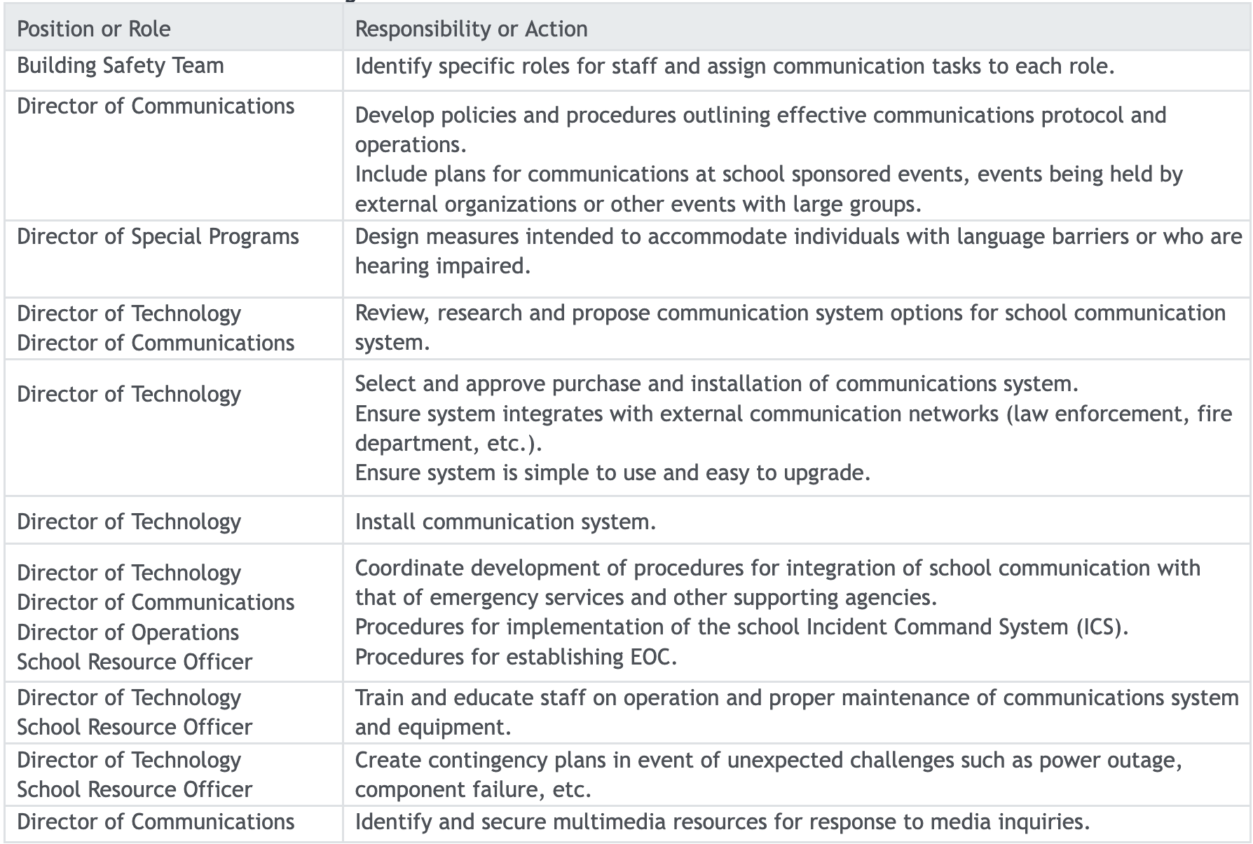

### During Emergency

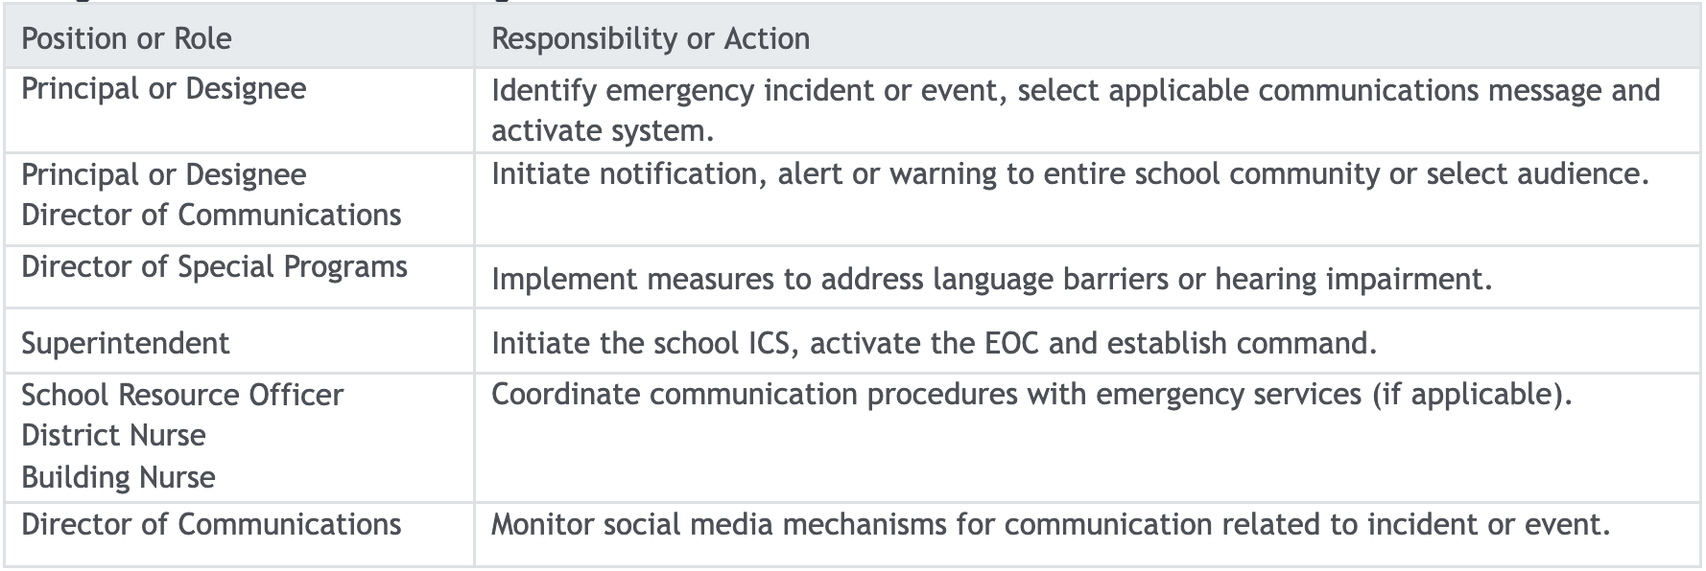

### After Emergency

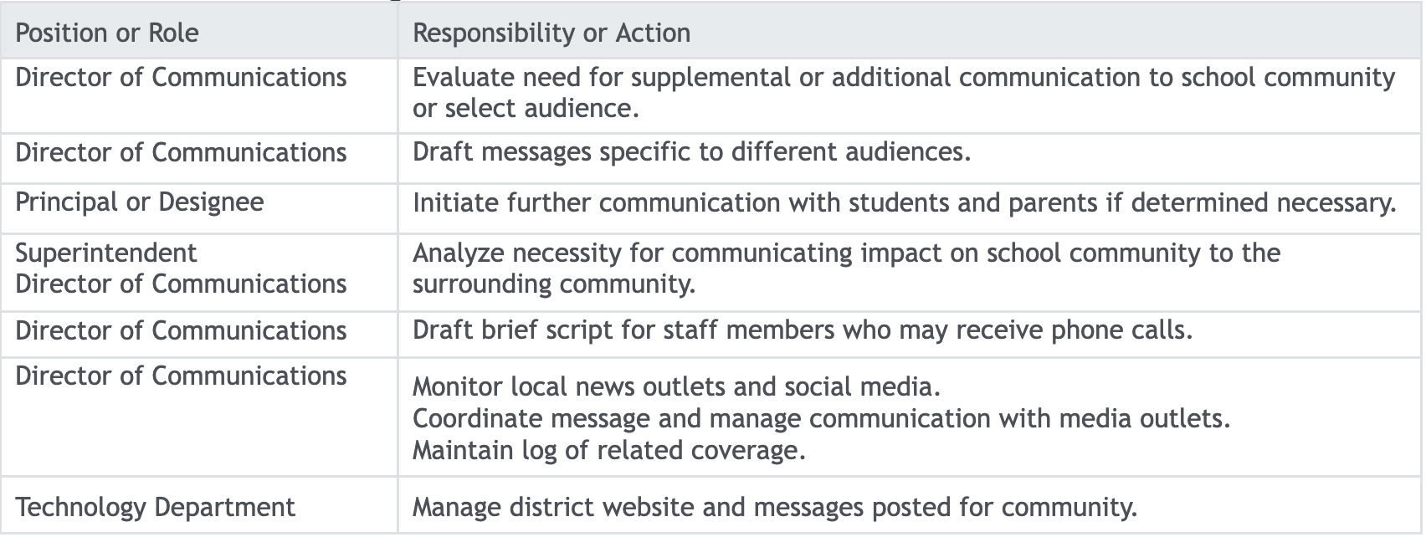

### Specific Incidents

#### Evacuation

* Establish communications procedure for external and internal communications.
* General communication with parents or guardians.
* Communicate and coordinate with media.

#### Reverse Evacuation

* Establish communication procedure for external and internal communications
* Communicate and coordinate with media.
* General communication with parents or guardians.

#### Lockdown

* General communication with parents or guardians. Communicate and coordinate with media.

#### Lockout

* General communication with parents or guardians.
* Communicate and coordinate with media.

#### Shelter-in-Place

* General communication with parents or guardians.
* Communicate and coordinate with media.

#### Family Reunification

* Establish and initiate communication procedures for maintaining emergency contact lists and contacting parents, guardians or emergency contacts.

#### Public Health Emergency

* Determine if notification to school community is necessary and coordinate notification.
* Notify parents or guardians.
* Manage communication with media and social media outlets.
* Inform parents and students of school operations using appropriate mechanisms.

# Emergency Response Guide for Parents/Guardians

Statistics consistently show that schools are among the safest places to be due to the strong commitment of educators, families, and our community to our students and schools. We strive to be proactive rather than reactive. This guide outlines the key elements of the state of preparedness in Kearney School District. We hope it will answer questions you have concerning our actions and intentions in the event of an emergency.

For consistency, we have developed the following terms to use:

* **Drill**: An activity that covers a specific safety circumstance and is designed to prepare your student to act quickly and minimize questions and fears should an emergency take place. State law requires fire, tornado, and other emergency drills, including an unannounced lockdown.
* **SRO**: School Resource Officer, a trained, certified and uniformed law enforcement officer assigned to schools to help build and maintain relationships between police, students, families, and employees.
* **Lock and Teach**: Lock and Teach is the term used when a non-threatening situation is in or around the building. Students remain in the classroom and class can go on as planned.
* **Lockdown**: Lockdown is the term used when there is a dangerous threat in close proximity of the building but is not inside the building. Occupants are kept in rooms or areas that are secured. There is no movement within the building. Lockdown procedures are followed.
* **A.L.I.C.E.**: Alert, Lockdown, Inform, Counter, Evacuate (A.L.I.C.E.) is the safety training staff and students undergo in their buildings. A.L.I.C.E. is the term used in the event of an intruder in a building.
* **Shelter-In-Place**: All occupants remain in the classroom/building. Movement within the building is at the building administrator’s discretion.
* **Evacuation**: Evacuation is the term used when a dangerous threat is in the building. Students and staff need to get out of the building.
* **Rally Point**: Area where students and employees are transported.
* **Reunification Point**: Location designated at a school or reunification site where families may pick up students. This location will be communicated to you at the time of an emergency.

As soon as possible, please **ensure your contact information in PowerSchool is current and accurate**, including who is authorized to pick up your student. We will use this information and multiple communication channels (phone calls, emails, text messages) to provide accurate and timely information in the event of an emergency.

If necessary, we may also use our district and school website, social media accounts and local news outlets to share important and timely information.

Explain to your student that **cell phones should not be used during an emergency unless directed by an adult**. Your student must pay attention to instructions from trained personnel.

*What you can expect if an emergency occurs*:

* The emergency plan will be implemented and the district/school emergency teams will respond.
* All appropriate emergency response agencies will be dispatched to the school.
* Depending on the situation, students and employees will be secured within the building or relocated to a Rally Point and Reunification Point.
* Families will be kept informed on the situation with as much detail as possible. The first and official way for us to contact you in an emergency is using our automated SchoolMessenger system. Please only rely on these official communications.
* In an emergency, phones are needed to manage the situation and lines must remain open. Calling could also put students and employees at risk in an intruder situation. For example, if they did not have time to turn down their ring volume, your call could potentially give away their hiding spot.
* You will not be allowed on school grounds during an emergency. Emergency personnel responding to the situation need the area clear to do their job. After emergency responders determine that a safe student release is possible, arrangements will be made to reunite students with their families. This will occur at a reunification site.
* Students will not be allowed to take their property (coat, backpack, etc.) with them in an emergency.

*After an Emergency*:

* You will be directed to the Reunification Point, and you will need photo identification.
* Students will only be released to a parent, guardian, or other adult listed on the student’s PowerSchool account. The individual picking up the student will be asked to sign a Student Release Form. This procedure is designed for your student’s protection and your peace of mind.
* Please be aware that reunification can be very time-consuming, and we appreciate your patience.
* It is important to remain calm as students are greatly influenced by their family’s sense of well-being. At the same time, families need to be compassionate listeners when their student speaks of an emergency. Please seek help from the school, district, or community resources if you/your student have concerns.

*Press Pause*

Families should be aware that Kearney School District will ask students and employees to “Press Pause,” or wait five minutes before communicating (calling, texting, posting, tweeting) in an emergency to give authorities sufficient time to assess the situation and communicate accurate information. This helps to avoid an environment that shares misinformation, which may escalate a situation. Teachers and/or administrators will give students the “green light” to utilize their devices.

Additionally, all Kearney School District employees, students, families, and community members are encouraged to report anything they see, hear, or are made aware of that may impact a school. If you see or hear something, say something. All KSD staff are trained to respond appropriately when they hear about potentially concerning situations. Anonymous tips can be shared using the Scholastic Crime Stoppers program by calling (816) 474-TIPS or visiting [KCCrimeStoppers.com](https://kccrimestoppers.com/sitemenu.aspx?ID=452&). KSD SRO Adam Kirkland can be reached at kirklanda@ksdr1.net. Call 911 if there is an immediate threat.

When providing information, please be as detailed as possible. Include the name of the school(s), person(s) involved, type of alleged activities, and when they occurred/may occur.

All threats are taken seriously. Police are notified, and officers and school administrators work together to thoroughly investigate any threat, whether it is made verbally, in writing, email, text message, or online. The earlier we know about a potential threat, the earlier an investigation can begin.

Anyone who makes a threat against a school could face criminal charges. If a student is involved in making a threat, the school/district will respond as outlined in the student handbook.

WARNING: it is forbidden to impersonate an official Kearney School District social media account or post false information about or from the school system under an anonymous account or alias. Depending on the nature of the post, such action may result in notification to local law enforcement. If made by an employee or student, it could result in disciplinary action.

The way in which we respond to an emergency is greatly influenced by the specifics of an incident. Our plans do not replace the authority of emergency personnel. Our employees work in full cooperation with these agencies.

For security reasons, components of our emergency plans are not publicly available.

# Emergency Preparedness in KSD

**Emergency Operations and Planning**:

* Development of a comprehensive district Emergency Operations Plan (EOP) in 2023
* Annual updates based on best practices research
* Regular meetings of the District Collaborative Planning Team to review safety needs and emergency plans

**Collaboration and Partnerships**:

* Partnerships with local emergency responders (Kearney Police Department, Kearney Fire & Rescue, Clay County Sheriff’s Office)
* Collaboration for meetings, training, and planning with emergency responders

**Communication and Notification Systems**:

* Implementation of the Scholastic Crime Stoppers text-a-tip program
* SchoolMessenger mass notification system for quick communication via telephone, email, SMS/text, and smartphone app

**Personnel Training and Safety Protocols**:

* State-mandated background checks and photo identification badges for all employees
* School safety plans, emergency response procedures, and A.L.I.C.E. training
* School Emergency Response Team at each school with ongoing training
* CPR, First Aid, and emergency equipment training for personnel
* Employee training sessions on roles and responsibilities during emergencies
* Training staff and students to identify and help prevent human trafficking

**Physical Safety Measures**:

* Presence of first aid kits, fire extinguishers, AED machines, bleeding control stations, Narcan®, etc.
* Controlled access equipment and protocols at all schools and the central office
* Visitor sign-in procedures and building access signage
* Security cameras are located throughout all school buildings

**Emergency Drills and Procedures**:

* Regular emergency response drills with students and employees (lockdown, fire, tornado, etc.)
* Training during employee meetings to orient them to emergency roles and responsibilities
* Establishment of threat assessment procedures

**Online Safety and Security**:

* Creation of an online Caregiver Corner with links to various resources
* Staff professional development for online safety and digital security of Personally Identifiable Information
* Providing families with online safety and security information through the Qustodio Parents App and KSD Online Safety Hub

**Special Education Services**

* Crisis Preventional Institute - teaching staff to prevent the escalation of situations before restraint is needed
* Professional development is provided on Adverse Childhood Experiences (ACEs), Trauma-Sensitive Schools, and suicide prevention and intervention.
* Special education employees hold monthly meetings at all school sites to provide technical assistance and direct support for employees with students having behavioral needs.
* Partnering with outside agencies as needed to provide expertise and additional resources

**Student Supports, Preventions, and Interventions**

* Integrated curriculum and programs that have been proven to increase school safety, including:
  + Bullying Prevention Programs
  + Digital Citizenship
  + Character Education
  + Social-Emotional lessons
  + Positive Behavioral Interventions and Supports (PBIS)
  + BULLDOGS Respect Campaign
  + KIND Clubs
* Individual student safety plans are developed with families to reinforce teaching self-regulation and behavior replacement strategies
* Alternate spaces are available to allow students to reset during dysregulation
* Multi-Tiered Support Systems - both academic and behavioral

**Personnel**

* School Resource Officer on staff
* Registered Nurses at all schools
* Counselors at all schools
* Three Social Workers on staff

# Emergency Communications Priority Checklist

**Our employees must be informed first**. They may receive inquiries and providing them with a script/guidance will help in ensuring consistent information is shared and to dispel rumors.

**Leverage all appropriate communication channels**. The more ways we convey and repeat our message, the more opportunities we have to share accurate information.

| AUDIENCE | LEAD | MEDIA |
| --- | --- | --- |
| Board of Education | Superintendent | * Face-to-Face * Phone Call * Text * Email |
| Cabinet | Superintendent  Individual Cabinet Members | * Face-to-Face * Phone Call * Text * Email |
| Principals & AD | Superintendent  Individual Cabinet Members | * Face-to-Face * Phone Call * Text * Email |
| School Leadership & Administrative Support | School Principal | * Face-to-Face * Phone Call * Text * Email |
| Employees (District) | Superintendent  Director of Communications  Other Cabinet Members | * Face-to-Face * Phone Call * Text * Email |
| Employees (School) | Principal  Assistant Principal  Director of Communications | * Face-to-Face * Phone Call * Text * Email |
| Parents/Guardians & Students (District) | Superintendent  Director of Communications  Other Cabinet Members | * SchoolMessenger (eblast, robocall, SMS & push notifications) * Website Alert Bar * Website Urgent News Post * District Social Media |
| Parents/Guardians & Students (School) | Principal  Assistant Principal  Director of Communications | * SchoolMessenger (eblast, robocall, SMS & push notifications) |
| Community | Superintendent  Director of Communications | * SchoolMessenger (Community 911 List) * Website Alert Bar * Website Urgent News Post * District Social Media |
| News Media | Superintendent  Director of Communications | * Press Release * Phone call * Text * Interviews |

# Emergency Scripts

These scripts are guides to use during an emergency. You will need to fill in the information in the parenthesis of the script. Each emergency is unique and the information to include will vary. The goal is to share first with staff and then with families within the first 15-20 minutes of a situation. In many cases, these scripts will just be the first of several messages that may be required during and after an emergency.

IMPORTANT: All emergency communications must be reviewed and approved by the Superintendent and or Director of Communications prior to distribution. If it is a district-wide message, also share the completed script with the Admin and PSUG Gmail lists.

## Active Shooter

*Robocall*

Hello. This is (TITLE AND NAME) with an important message. At (TIME) on (DATE), an active shooter was reported at (LOCATION/SCHOOL). Students and employees (EVACUATED TO THE SCHOOL’S DESIGNATED RALLY POINT AND WILL REMAIN THERE FOR THE IMMEDIATE FUTURE/WENT INTO LOCKDOWN). Emergency personnel and first responders are on the scene. Traffic in and out of the area is restricted, and you are asked to avoid this area until further notice. Please do not call the school or your student. Additional information will be communicated to you as soon as possible. Thank you.

*Eblast & Website*

Be advised that at (TIME) on (DATE), an active shooter was reported at (LOCATION/SCHOOL). Students and employees (EVACUATED TO THE SCHOOL’S DESIGNATED RALLY POINT AND WILL REMAIN THERE FOR THE IMMEDIATE FUTURE/WENT INTO LOCKDOWN). Emergency personnel and first responders are on the scene. Traffic in and out of the area is restricted, and you are asked to avoid this area until further notice. Please do not call the school or your student. Additional information will be communicated to you as soon as possible.

*Text Message*

(SCHOOL) alert: there is an emergency at your student’s school. Please check your email/voicemail for more information.

## All Clear

*Robocall*

Hello. This is (TITLE AND NAME) with an important message. At (TIME) on (DATE), the (EMERGENCY SITUATION) at (SCHOOL) ended. Traffic in and out of the area is no longer restricted, and we have resumed normal business operations. Thank you.

*Eblast & Website*

At (TIME) on (DATE), the (EMERGENCY SITUATION) at (SCHOOL) ended. Traffic in and out of the area is no longer restricted, and we have resumed normal business operations.

*Text Message*

(SCHOOL) alert: the emergency at your student’s school has ended. Check your email for details.

## Biological/Chemical Spill/Threat (No Exposure)

*Robocall*

Hello. This is (TITLE AND NAME) with an important message. At (TIME) on (DATE), a (BIOLOGICAL/CHEMICAL) (SPILL/THREAT) was reported at (LOCATION/SCHOOL). Students and employees (HAVE BEEN EVACUATED TO THE DESIGNATED ALTERNATE SITE AND WILL REMAIN THERE FOR THE IMMEDIATE FUTURE/WENT INTO LOCKDOWN). Emergency personnel and first responders are on the scene. Traffic in and out of the area is restricted, and you are asked to avoid this area until further notice. Additional information will be communicated to you as soon as possible. Thank you.

*Eblast & Website*

At (TIME) on (DATE), a (BIOLOGICAL/CHEMICAL) (SPILL/THREAT) was reported at (LOCATION/SCHOOL). Students and employees (HAVE BEEN EVACUATED TO THE DESIGNATED ALTERNATE SITE AND WILL REMAIN THERE FOR THE IMMEDIATE FUTURE/WENT INTO LOCKDOWN). Emergency personnel and first responders are on the scene. Traffic in and out of the area is restricted, and you are asked to avoid this area until further notice. Additional information will be communicated to you as soon as possible.

*Text Message*

(SCHOOL) alert: there is an emergency at your student’s school. Please check your email/voicemail for more information.

## Biological/Chemical Spill/Threat (Exposure)

*Robocall*

Hello. This is (TITLE AND NAME) with an important message. At (TIME) on (DATE), a (BIOLOGICAL/CHEMICAL) (SPILL/THREAT) and possible exposure was reported at (LOCATION/SCHOOL). Students and employees (HAVE BEEN EVACUATED TO THE DESIGNATED ALTERNATE SITE AND WILL REMAIN THERE FOR THE IMMEDIATE FUTURE/WENT INTO LOCKDOWN). Emergency personnel and first responders are on the scene. Traffic in and out of the area is restricted, and you are asked to avoid this area until further notice. Additional information will be communicated to you as soon as possible. Thank you.

*Eblast & Website*

At (TIME) on (DATE), a (BIOLOGICAL/CHEMICAL) (SPILL/THREAT) and possible exposure was reported at (LOCATION/SCHOOL). Students and employees (HAVE BEEN EVACUATED TO THE DESIGNATED ALTERNATE SITE AND WILL REMAIN THERE FOR THE IMMEDIATE FUTURE/WENT INTO LOCKDOWN). Emergency personnel and first responders are on the scene. Traffic in and out of the area is restricted, and you are asked to avoid this area until further notice. Additional information will be communicated to you as soon as possible.

*Text Message*

(SCHOOL) alert: there is an emergency at your student’s school. Please check your email/voicemail for more information.

## Bomb Threat (No Evacuation)

*Robocall*

Hello. This is (TITLE AND NAME) with an important message. At (TIME) on (DATE), a bomb threat was reported at (LOCATION/SCHOOL). Emergency personnel responded to the scene, immediately investigated and swept the building with officers and canines in accordance with Kearney Police Department protocol. Emergency personnel thoroughly investigated the building and cleared the school. We will resume normal operations at (TIME) on (DATE). If you have any questions, please contact your school administrator. Thank you.

*Eblast & Website*

At (TIME) on (DATE), a bomb threat was reported at (LOCATION/SCHOOL). Emergency personnel responded to the scene, immediately investigated and swept the building with officers and canines in accordance with Kearney Police Department protocol. Emergency personnel thoroughly investigated the building and cleared the school. We will resume normal operations at (TIME) on (DATE). If you have any questions, please contact your school administrator.

*Text Message*

(SCHOOL) alert: there was a threat reported at your student’s school. Please check your email/voicemail for more information.

## Contaminated Food/Water Supply

*Robocall*

Hello. This is (TITLE AND NAME) with an important message. At (TIME) on (DATE), it was reported that there may be contaminated (FOOD/WATER) at (LOCATION/SCHOOL). The school has been place in a Lock & Teach status and access to food and water at the school is restricted. School administrators and our school nurse are working to identify and treat any students who may have been exposed. Traffic in and out of the area is restricted, and you are asked to avoid this area until further notice. Additional information will be communicated to you as soon as possible. Thank you.

*Eblast & Website*

At (TIME) on (DATE), it was reported that there may be contaminated (FOOD/WATER) at (LOCATION/SCHOOL). The school has been place in a Lock & Teach status and access to food and water at the school is restricted. School administrators and our school nurse are working to identify and treat any students who may have been exposed. Traffic in and out of the area is restricted, and you are asked to avoid this area until further notice. Additional information will be communicated to you as soon as possible. Thank you.

*Text Message*

(SCHOOL) alert: there is an emergency at your student’s school. Please check your email/voicemail for more information.

## Bomb Threat (Evacuation)

*Robocall*

Hello. This is (TITLE AND NAME) with an important message. At (TIME) on (DATE), a bomb threat was reported at (LOCATION/SCHOOL). Students and employees evacuated to the school’s designated alternate site and will remain there for the immediate future. Emergency personnel and first responders are on the scene. Traffic in and out of the area is restricted, and you are asked to avoid this area until further notice. Additional information will be communicated to you as soon as possible. Thank you.

*Eblast & Website*

At (TIME) on (DATE), a bomb threat was reported at (LOCATION/SCHOOL). Students and employees evacuated to the school’s designated alternate site and will remain there for the immediate future. Emergency personnel and first responders are on the scene. Traffic in and out of the area is restricted, and you are asked to avoid this area until further notice. Additional information will be communicated to you as soon as possible. Thank you.

*Text Message*

(SCHOOL) alert: there is an emergency at your student’s school. Please check your email/voicemail for more information.

## Criminal Threats/Actions (Credible)

*Robocall*

Hello. This is (TITLE AND NAME) with an important message. At (TIME) on (DATE), we received information about a threat of violence made by a student. Immediate action was taken by the school administration and the (LAW ENFORCEMENT AGENCY) to investigate and the threat was determined to be credible. The school has been placed in a (LOCK & TEACH/LOCKDOWN) status as we respond to help ensure the safety of our students. Making a threat on a public school can have serious consequences for the perpetrator. Thank you to the individuals who reported the threat to the administration. Traffic in and out of the area is restricted, and you are asked to avoid this area until further notice. Additional information will be communicated to you as soon as possible. Thank you.

*Eblast*

At (TIME) on (DATE), we received information about a threat of violence made by a student. Immediate action was taken by the school administration and the (LAW ENFORCEMENT AGENCY) to investigate and the threat was determined to be credible. The school has been placed in a (LOCK & TEACH/LOCKDOWN) status as we respond to help ensure the safety of our students. Making a threat on a public school can have serious consequences for the perpetrator. Thank you to the individuals who reported the threat to the administration. Traffic in and out of the area is restricted, and you are asked to avoid this area until further notice. Additional information will be communicated to you as soon as possible. Thank you.

*Text Message*

(SCHOOL) alert: there is an emergency at your student’s school. Please check your email/voicemail for more information.

## Criminal Threats/Actions (Not Credible)

*Eblast*

Hello. This is (TITLE AND NAME) with an important message. At (TIME) on (DATE), we received information about a threat of violence made by a student. Immediate action was taken by the school administration and the (LAW ENFORCEMENT AGENCY) to investigate and the threat was determined not to be credible. While not credible, we wanted to make you aware of the situation and let you know it is safe to send your student to school. Making a threat on a public school can have serious consequences for the perpetrator. Thank you to the individuals who reported the threat to the administration. The safety of our students and employees is our top priority, and we appreciate your continued support of a safe environment for our students and employees.

## Cyber Attack/Threat

REFER TO: CYBER EVENTS & INCIDENTS

*Robocall*

Hello. This is (TITLE AND NAME) with an important message. At (TIME) on (DATE), a cyber (EVENT/INCIDENT) was reported at (LOCATION/SCHOOL) that has impacted our [SYSTEMS/NETWORKS/DATABASES]. The safety and security of our students, staff, and sensitive information remain our utmost priority, and we are taking immediate action to address this situation.Our IT team is working diligently to assess the extent of the attack/threat and restore normal operations as soon as possible. Additional information will be communicated to you as soon as it becomes available. Thank you.

*Eblast & Website*

At (TIME) on (DATE), a cyber (EVENT/INCIDENT) was reported at (LOCATION/SCHOOL) that has impacted our [SYSTEMS/NETWORKS/DATABASES]. The safety and security of our students, staff, and sensitive information remain our utmost priority, and we are taking immediate action to address this situation.Our IT team is working diligently to assess the extent of the attack/threat and restore normal operations as soon as possible. Additional information will be communicated to you as soon as it becomes available.

*Text Message*

(SCHOOL) alert: a cyber (EVENT/INCIDENT) was reported at your student’s school. Check your email/voicemail for more information.

## Death - Accidental/Incidental (Suicide/Overdose)

*Robocall*

Hello. This is (TITLE AND NAME) with an important message. At (TIME) on (DATE), an (ACCIDENT/INCIDENT) occurred while (DESCRIPTION OF EVENT), resulting in the death of an (EMPLOYEE/STUDENT) at (LOCATION). Emergency personnel responded to the (ACCIDENT/INCIDENT). The identity of the deceased is being withheld until the family is notified. Further information will be released by the (LAW ENFORCEMENT AGENCY) when it becomes available. Thank you.

*Eblast & Website*

At (TIME) on (DATE), an (ACCIDENT/INCIDENT) occurred while (DESCRIPTION OF EVENT), resulting in the death of an (EMPLOYEE/STUDENT) at (LOCATION). Emergency personnel responded to the (ACCIDENT/INCIDENT). The identity of the deceased is being withheld until the family is notified. Further information will be released by the (LAW ENFORCEMENT AGENCY) when it becomes available.

*Text Message*

(SCHOOL) alert: an accident involving an (EMPLOYEE/STUDENT) has occurred. Please check your email/voicemail for more information.

## Dangerous Animal (No Evacuation)

*Robocall*

Hello. This is (TITLE AND NAME) with an important message. At (TIME) on (DATE), a dangerous animal was reported near but not in (LOCATION/SCHOOL). The school has been placed in a (LOCK & TEACH/LOCKDOWN) status. Emergency personnel and first responders are on the scene. Traffic in and out of the area is restricted, and you are asked to avoid this area until further notice. Additional information will be communicated to you as soon as possible. Thank you.

*Eblast & Website*

At (TIME) on (DATE), a dangerous animal was reported near but not in (LOCATION/SCHOOL). The school has been placed in a (LOCK & TEACH/LOCKDOWN) status. Emergency personnel and first responders are on the scene. Traffic in and out of the area is restricted, and you are asked to avoid this area until further notice. Additional information will be communicated to you as soon as possible. Thank you.

*Text Message*

(SCHOOL) alert: there was a dangerous animal reported near your student’s school. Please check your email/voicemail for more information.

## Dangerous Animal (Evacuation)

*Robocall*

Hello. This is (TITLE AND NAME) with an important message. At (TIME) on (DATE), a dangerous animal was reported at (LOCATION/SCHOOL). Students and employees evacuated to the school’s designated alternate site and will remain there for the immediate future. Emergency personnel and first responders are on the scene. Traffic in and out of the area is restricted, and you are asked to avoid this area until further notice. Additional information will be communicated to you as soon as possible. Thank you.

*Eblast & Website*

At (TIME) on (DATE), a dangerous animal was reported at (LOCATION/SCHOOL). Students and employees evacuated to the school’s designated alternate site and will remain there for the immediate future. Emergency personnel and first responders are on the scene. Traffic in and out of the area is restricted, and you are asked to avoid this area until further notice. Additional information will be communicated to you as soon as possible. Thank you.

*Text Message*

(SCHOOL) alert: there is a dangerous animal at your student’s school. Please check your email/voicemail for more information.

## Dysregulated Student

*Eblast*

At approximately (TIME) on (DATE), a student became dysregulated (disruptive) in your student’s classroom. This did result in a brief interruption of the class while employees intervened. No students or employees were harmed. If you or your student has questions or concerns, please speak with (SCHOOL COUNSELOR/SOCIAL WORKER/TEACHER/PRINCIPAL).

## Downed Electrical Line

*Robocall*

Hello. This is (TITLE AND NAME) with an important message. At (TIME) on (DATE), a downed electrical line was reported at (LOCATION). Students and employees are safe and have been asked to stay inside until further notice. Emergency personnel are on the scene. Traffic in and out of the area is restricted, and you are asked to avoid this area until further notice. Additional information will be communicated to you as soon as it becomes available. Thank you.

*Eblast & Website*

At (TIME) on (DATE), a downed electrical line was reported at (LOCATION). Students and employees are safe and have been asked to stay inside until further notice. Emergency personnel are on the scene. Traffic in and out of the area is restricted, and you are asked to avoid this area until further notice. Additional information will be communicated to you as soon as it becomes available.

*Text Message*

(SCHOOL) alert: there is a downed electrical line near your student’s school. Check your email/voicemail for more information.

## Earthquake

*Robocall*

Hello. This is (TITLE AND NAME) with an important message. At (TIME) on (DATE), an earthquake was reported at (SCHOOL NAME). The building has been evacuated while district employees and emergency responders attend to injuries and assess the structure. Traffic in and out of the area may be restricted, and you are asked to avoid this area until further notice. Additional information will be communicated to you as soon as it becomes available. Thank you.

*Eblast & Website*

At (TIME) on (DATE), an earthquake was reported at (SCHOOL NAME). The building has been evacuated while district employees and emergency responders attend to injuries and assess the structure. Traffic in and out of the area may be restricted, and you are asked to avoid this area until further notice. Additional information will be communicated to you as soon as it becomes available.

*Text Message*

(SCHOOL) alert: an earthquake has been reported at your student’s school. Check email/voicemail for more information.

## Explosion

*Robocall*

Hello. This is (TITLE AND NAME) with an important message. At (TIME) on (DATE), an explosion occurred (AT/NEAR) (LOCATION). Students and employees evacuated to the school’s designated alternate site and will remain there for the immediate future. Emergency personnel and first responders are on scene and determined that (ANY DETAILS YOU CAN PROVIDE). Traffic in and out of the area is restricted, and you are asked to avoid this area until further notice. Additional information will be communicated to you as soon as possible. Thank you.

*Eblast & Website*

At (TIME) on (DATE), an explosion occurred (AT/NEAR) (LOCATION). Students and employees evacuated to the school’s designated alternate site and will remain there for the immediate future. Emergency personnel and first responders are on scene and determined that (ANY DETAILS YOU CAN PROVIDE). Traffic in and out of the area is restricted, and you are asked to avoid this area until further notice. Additional information will be communicated to you as soon as possible.

*Text Message*

(SCHOOL NAME) alert: there is an emergency at your student’s school. Please check your email/voicemail for more information.

## Fire

*Robocall*

Hello. This is (TITLE AND NAME) with an important message. At (TIME) on (DATE), a fire occurred at (LOCATION). Students and employees evacuated to the school’s designated alternate site and will remain there for the immediate future. Emergency personnel and first responders are on the scene. Traffic in and out of the area is restricted, and you are asked to avoid this area until further notice. Additional information will be communicated to you as soon as it becomes available. Thank you.

*Eblast & Website*

At (TIME) on (DATE), a fire occurred at (LOCATION). Students and employees evacuated to the school’s designated alternate site and will remain there for the immediate future. Emergency personnel and first responders are on the scene. Traffic in and out of the area is restricted, and you are asked to avoid this area until further notice. Additional information will be communicated to you as soon as it becomes available.

*Text Message*

(SCHOOL) alert: there is an emergency at your student’s school. Please check your email/voicemail for more information.

## Fire Alarm Pulled

*Eblast*

At (TIME) on (DATE), one of our students pulled a fire alarm at (SCHOOL). Students and staff quietly and calmly followed our fire drill procedure and went outside. Kearney Fire & Rescue Protection District responders came and cleared the school in accordance with their procedures. Again, there was no emergency situation involved. If you have any questions or concerns, please call the school office at (PHONE NUMBER).

## Food Poisoning

*Robocall*

Hello. This is (TITLE AND NAME) with an important message. Over (PERIOD OF TIME), there have been multiple cases reported of food poisoning at (SCHOOL NAME). The exact cause is (CAUSE/UNKNOWN), but those affected have had the following symptoms in common: (SYMPTOMS). If you experience any symptoms that lead you to believe you are sick, please contact your primary care provider. You can find additional information on our website at (WEBSITE URL). Thank you.

*Eblast & Website*

Over (PERIOD OF TIME), there have been multiple cases reported of food poisoning at (SCHOOL NAME). The exact cause is (CAUSE/UNKNOWN), but those affected have had the following symptoms in common: (SYMPTOMS). If you experience any symptoms that lead you to believe you are sick, please contact your primary care provider. You can find additional information on our website at (WEBSITE URL).

*Text Message*

(SCHOOL) alert: multiple cases of food poisoning have been reported. Please check your email/voicemail for more information.

## Gas Leak

*Robocall*

Hello. This is (TITLE AND NAME) with an important message. At (TIME) on (DATE), a gas leak occurred at (LOCATION). Students and employees are safe and (HAVE BEEN ASKED TO STAY INSIDE UNTIL FURTHER NOTICE/HAVE EVACUATED TO AN ALTERNATE SITE AND WILL REMAIN THERE FOR THE IMMEDIATE FUTURE). Emergency personnel and first responders are on scene. Traffic in and out of the area is restricted, and you are asked to avoid this area until further notice. Additional information will be communicated to you as soon as it becomes available. Thank you.

*Eblast & Website*

At (TIME) on (DATE), a gas leak occurred at (LOCATION). Students and employees are safe and (HAVE BEEN ASKED TO STAY INSIDE UNTIL FURTHER NOTICE/HAVE EVACUATED TO AN ALTERNATE SITE AND WILL REMAIN THERE FOR THE IMMEDIATE FUTURE). Emergency personnel and first responders are on scene. Traffic in and out of the area is restricted, and you are asked to avoid this area until further notice. Additional information will be communicated as soon as it becomes available.

*Text Message*

(SCHOOL) alert: there is a gas leak at your student’s school. Please check your email and/or voicemail for more information.

## Hazardous Materials Incident

*Robocall*

Hello. This is (TITLE AND NAME) with an important message. At (TIME) on (DATE), a hazardous materials incident occurred at (LOCATION). Students and employees are safe and have been asked to stay inside until further notice. Emergency personnel and first responders are on scene. Traffic in and out of the area is restricted, and you are asked to avoid this area until further notice. Additional information will be communicated to you as soon as it becomes available. Thank you.

*Eblast & Website*

At (TIME) on (DATE), a hazardous materials incident occurred at (LOCATION). Students and employees are safe and have been asked to stay inside until further notice. Emergency personnel and first responders are on scene. Traffic in and out of the area is restricted, and you are asked to avoid this area until further notice. Additional information will be communicated to you as soon as it becomes available.

*Text Message*

(SCHOOL) alert: please check your email/voicemail for information regarding an incident at your student’s school.

## Health Emergency/Communicable Disease (Not contagious)

*Eblast*

At (TIME) on (DATE), (SCHOOL) was notified of a (STUDENT/EMPLOYEE) diagnosed with (ILLNESS/DISEASE). The individual(S) (IS/ARE) receiving care and (IS/ARE) no longer attending school. This (ILLNESS/DISEASE) is not highly contagious and can only be transmitted by (VECTORS). Any student or employee exhibiting (SYMPTOMS) or who thinks they have come in contact with the individual, should contact their primary care provider. If you have any questions, please call the main office at (PHONE NUMBER). Thank you.

*Text Message*

(SCHOOL) alert: please check your email/voicemail for information regarding a health-related issue at your student’s school.

## Intruder

*Robocall*

Hello. This is (TITLE AND NAME) with an important message. At (TIME) on (DATE), an intruder was reported at (LOCATION/SCHOOL). Students and employees (EVACUATED TO THE SCHOOL’S DESIGNATED RALLY POINT AND WILL REMAIN THERE FOR THE IMMEDIATE FUTURE/WENT INTO LOCKDOWN). Emergency personnel and first responders are on the scene. Traffic in and out of the area is restricted, and you are asked to avoid this area until further notice. Please do not call the school or your student. Additional information will be communicated to you as soon as possible. Thank you.

*Eblast & Website*

Be advised that at (TIME) on (DATE), an intruder was reported at (LOCATION/SCHOOL). Students and employees (EVACUATED TO THE SCHOOL’S DESIGNATED RALLY POINT AND WILL REMAIN THERE FOR THE IMMEDIATE FUTURE/WENT INTO LOCKDOWN). Emergency personnel and first responders are on the scene. Traffic in and out of the area is restricted, and you are asked to avoid this area until further notice. Please do not call the school or your student. Additional information will be communicated to you as soon as possible.

*Text Message*

(SCHOOL) alert: there is an emergency at your student’s school. Please check your email/voicemail for more information.

## Law Enforcement Emergency (Off-Campus)

*Robocall*

Hello. This is (TITLE AND NAME) with an important message. At (TIME) on (DATE), law enforcement asked (SCHOOL) to go into a (LOCKDOWN/LOCK & TEACH) due to a non-school related incident near the school. Students and employees are safe and have been asked to stay inside until further notice. Traffic in and out of the area may be restricted, and you are asked to avoid this area until further notice. Additional information will be communicated to you as soon as it becomes available. Thank you.

*Eblast & Website*

At (TIME) on (DATE), law enforcement asked (SCHOOL) to go into a (LOCKDOWN/LOCK & TEACH) due to a non-school related incident near the school. Students and employees are safe and have been asked to stay inside until further notice. Traffic in and out of the area may be restricted, and you are asked to avoid this area until further notice. Additional information will be communicated to you as soon as it becomes available.

*Text Message*

(SCHOOL) alert: law enforcement has asked us to go into (LOCKDOWN/LOCK & TEACH). More information to come.

## Lockdown

*Robocall*

Hello. This is (TITLE AND NAME) with an important message. At (TIME) on (DATE), (SCHOOL) went into a Lockdown due to (DESCRIBE INCIDENT). Employees have secured the areas for which they are responsible and they and students will stay inside until further notice. You are asked to avoid this area until further notice. Please do not call or come to the school. Additional information will be communicated to you as soon as possible. Thank you.

*Eblast & Website*

At (TIME) on (DATE), (SCHOOL) went into a lockdown due to (DESCRIBE INCIDENT). Employees have secured the areas for which they are responsible and they and students will stay inside until further notice. You are asked to avoid this area until further notice. Please do not call or come to the school. Additional information will be communicated to you as soon as possible.

*Text Message*

(SCHOOL) alert: our school is in Lockdown. Check your email or voicemail for more information.

## Lock & Teach

Robocall

Hello. This is (TITLE AND NAME) with an important message. At (TIME) on (DATE), (SCHOOL) went into a Lock & Teach status due to (DESCRIBE INCIDENT). Students and employees are safe and have been asked to stay inside until further notice. (Traffic in and out of the area is restricted, and you are asked to avoid this area until further notice). Additional information will be communicated to you as soon as it becomes available. Thank you.

Eblast & Website

At (TIME) on (DATE), (SCHOOL) went into a Lock & Teach status due to (DESCRIBE INCIDENT). Students and employees are safe and have been asked to stay inside until further notice. (Traffic in and out of the area is restricted, and you are asked to avoid this area until further notice). Additional information will be communicated to you as soon as it becomes available.

Text Message

(SCHOOL) alert: our school is in a Lock & Teach status. Check email and/or voicemail for more information.

## Medical Response

*Eblast*

At (TIME) on (DATE), emergency personnel responded to a medical emergency at (SCHOOL). In order to allow medical responders quick access to the individual, we went into a Lock & Teach status. All students and employees remained in their classrooms until the Lock & Teach was lifted at approximately (TIME).

*Text Message*

(SCHOOL) alert: please check your email/voicemail for more information about a medical response at our school today.

Missing Student/Kidnapping

Robocall

Hello. This is (TITLE AND NAME) with an important message. [STUDENT NAME], [GRADE/AGE], has been reported missing from [LOCATION/SCHOOL] since [DATE/TIME]. The school has been placed in a Lock & Teach status. Local law enforcement authorities have been notified, and they are actively investigating the situation. If you have any information that may be helpful in locating this student or if you notice any suspicious activity, please contact 911 immediately. Additional information will be communicated to you as soon as it becomes available. Thank you.

Eblast

[STUDENT NAME], [GRADE/AGE], has been reported missing from [LOCATION/SCHOOL] since [DATE/TIME]. The school has been placed in a Lock & Teach status. Local law enforcement authorities have been notified, and they are actively investigating the situation. If you have any information that may be helpful in locating this student or if you notice any suspicious activity, please contact 911 immediately. Additional information will be communicated to you as soon as it becomes available. Thank you.

Text Message

(SCHOOL) alert: a student has been reported missing. Please check your email/voicemail for more information.

## Power Failure (Remain On-Site)

*Eblast & Website*

At (TIME) on (DATE), a power failure was reported at (SCHOOL). A restoration crew is on the scene and repairs are underway. Students and employees are safe inside and there (IS/WAS) no immediate need for an evacuation. Power (IS ESTIMATED TO BE/WAS) restored by approximately (TIME).

*Text Message*

(SCHOOL) alert: our school is experiencing a power failure. Students and staff are safe inside. More information to come.

## Pandemic - Health Emergency/Communicable Disease

*Robocall*

Hello. This is (TITLE AND NAME) with an important message. At (TIME) on (DATE), (SCHOOL) was notified of a (STUDENT/EMPLOYEE) diagnosed with (ILLNESS/DISEASE). The individual(S) (IS/ARE) receiving care and (IS/ARE) no longer attending school. This (ILLNESS/DISEASE) is highly contagious and can be transmitted by (VECTORS). Any student or employee exhibiting (SYMPTOMS), or who thinks they have come in contact with the individual, should contact their primary care provider. We are working with the Clay County Public Health Department to respond appropriately. If you have any questions, please call the main office at (PHONE NUMBER). Thank you.

*Eblast & Website*

At (TIME) on (DATE), (SCHOOL) was notified of a (STUDENT/EMPLOYEE) diagnosed with (ILLNESS/DISEASE). The individual(S) (IS/ARE) receiving care and (IS/ARE) no longer attending school. This (ILLNESS/DISEASE) is highly contagious and can be transmitted by (VECTORS). Any student or employee exhibiting (SYMPTOMS), or who thinks they have come in contact with the individual, should contact their primary care provider. We are working with the Clay County Public Health Department to respond appropriately. If you have any questions, please call the main office at (PHONE NUMBER).

*Text Message*

(SCHOOL) alert: please check your email/voicemail for information regarding a health-related issue at your student’s school.

## Power Failure (Use Alternate Site)

*Robocall*

Hello. This is (TITLE AND NAME) with an important message. At (TIME) on (DATE), a power failure was reported at (SCHOOL). Due to concerns during the outage, students and employees were relocated to their alternate location. Kearney Fire & Rescue was on the scene, determined (ISSUE) to be at fault, and has since determined the school safe to resume operations. At this time, students and employees have returned to their school. Thank you.

*Eblast & Website*

At (TIME) on (DATE), a power failure was reported at (SCHOOL). Due to concerns during the outage, students and employees were relocated to their alternate location. Kearney Fire & Rescue was on the scene, determined (ISSUE) to be at fault, and has since determined the school safe to resume operations. At this time, students and employees have returned to their school.

Text Message

(SCHOOL) alert: our school is experiencing a power failure. Students and staff relocated. Check email/voicemail for more information.

## Reunification

*Robocall*

Hello. This is (TITLE AND NAME) with an important message. (SCHOOL) has been evacuated in response to today’s incident. All students and employees are being transported, and at this time, parents/guardians can come to (REUNIFICATION SITE) to pick up their student. You must bring photo identification in order to be reunified. Thank you.

*Eblast & Website*

(SCHOOL) has been evacuated in response to today’s incident. All students and employees are being transported, and at this time, parents/guardians can come to (REUNIFICATION SITE) to pick up their student. You must bring photo identification in order to be reunified.

*Text Message*

(SCHOOL) alert: please come to (REUNIFICATION SITE) to pick up your student. Must bring a photo ID.

## Shooting (Off Campus)

*Eblast*

The shootings that occurred on (TIME, DATE, PLACE) are terrible and shocking. This incident can take a toll on the emotional and mental well-being of children and adults. Our schools are prepared to provide additional support for students and staff members. Please contact your child’s school counselor if you believe your child needs extra support as a result of this terrible incident. Please call or text 988 to connect at any time with a mental health professional if you are having overwhelming feelings or experiencing a mental health crisis and need immediate support. Here are some suggestions from the American Psychological Association for parents/guardians as they help their children cope with this incident: [Helping your children manage distress in the aftermath of a shooting](https://www.apa.org/topics/gun-violence-crime/shooting-aftermath). Please take care of yourself and your family, and let us know how we can be of assistance.

## Student Shot (Off Campus)

*Eblast*

Kearney School District has been informed that one of our students was injured during the shootings that occurred at (TIME, DATE, PLACE). Our first concern at this time is for this child and their family. We are offering them every support possible. Extra support is also being provided for staff and students who know and are friends with this victim. Please contact your child’s school counselor if you believe your child needs additional support as a result of this terrible incident. We will continue to do everything we can to help the victim and their family and wish this student a swift and full recovery. The identity of the injured student is being withheld. Further information will be released publicly when the family and law enforcement agencies decide to do so.

*Text Message*

Please check your email for an important message from KSD about a student who was injured in an OFF-CAMPUS shooting.

## Structural Issue/Failure

*Robocall*

Hello. This is (TITLE AND NAME) with an important message. At (TIME) on (DATE), a sinkhole was reported at (SCHOOL NAME). The building has been evacuated while district employees and emergency responders assess the structure. Traffic in and out of the area may be restricted, and you are asked to avoid this area until further notice. Additional information will be communicated to you as soon as it becomes available. Thank you.

*Eblast & Website*

At (TIME) on (DATE), a sinkhole was reported at (SCHOOL NAME). The building has been evacuated while district employees and emergency responders assess the structure. Traffic in and out of the area may be restricted, and you are asked to avoid this area until further notice. Additional information will be communicated to you as soon as it becomes available.

*Text Message*

(SCHOOL) alert: a sinkhole has been reported at your student’s school. Check email/voicemail for more information.

## Snow Day - Parents/Guardians (AM Notification)

ONLY SENT BY DIRECTOR OF COMMUNICATIONS & COMMUNITY RELATIONS OR OTHER DESIGNATED PERSONNEL

*Robocall, Eblast & Website*

Kearney School District is canceling classes at all of our schools for today, <<%Date%>>, due to the winter weather. This cancelation also includes Kids Club, Puppy Pound, Forest Friends and Acorn Patch. Stay safe and warm!

*Text Message*

KSD classes, including Kids Club, Puppy Pound, Forest Friends and Acorn Patch, are canceled for today, <<%Date%>>, due to the winter weather. Stay warm and safe!

## Snow Day - Parents/Guardians (PM Notification)

ONLY SENT BY DIRECTOR OF COMMUNICATIONS & COMMUNITY RELATIONS OR OTHER DESIGNATED PERSONNEL

*Robocall, Eblast & Website*

Kearney School District is canceling classes at all of our schools for tomorrow, <<%Tomorrow's Date%>>, due to the winter weather. This cancelation also includes Kids Club, Puppy Pound, Forest Friends and Acorn Patch. Stay safe and warm!

*Text Message*

KSD classes, including Kids Club, Puppy Pound, Forest Friends and Acorn Patch, are canceled tomorrow, <<%Tomorrow's Date%>>, due to the winter weather. Stay warm and safe!

## Snow Day - Staff (AM Notification)

ONLY SENT BY DIRECTOR OF COMMUNICATIONS & COMMUNITY RELATIONS OR OTHER DESIGNATED PERSONNEL

*Robocall & Eblast*

We are canceling classes today, <<%Date%>>, due to the winter weather. This cancelation includes Kids Club, Puppy Pound, Forest Friends and Acorn Patch. This will be a work day for staff. You will be expected to take leave if you decide to not work. Most school staff have the option to work from home during this cancelation. Contact your supervisor if you have any questions about whether you can work remotely or are expected to report to your district work location. Stay safe and warm!

*Text Message*

Team KSD: classes are canceled today, <<%Date%>>, due to winter weather. Contact your supervisor if you have questions. Stay safe and warm!

## Snow Day - Staff (PM Notification)

ONLY SENT BY DIRECTOR OF COMMUNICATIONS & COMMUNITY RELATIONS OR OTHER DESIGNATED PERSONNEL

*Robocall & Eblast*

We are canceling classes at all of our schools for tomorrow, <<%Tomorrow's Date%>>, due to the winter weather. This cancelation also includes Kids Club, Puppy Pound, Forest Friends and Acorn Patch. This will be a work day for staff. You will be expected to take leave if you decide to not work. Most school staff have the option to work from home during this cancelation. Contact your supervisor if you have any questions about whether you can work remotely or are expected to report to your district work location. Stay safe and warm!

*Text Message*

Team KSD: classes are canceled tomorrow, <<%Tomorrow's Date%>>, due to winter weather. Contact your supervisor if you have questions. Stay safe and warm!

## Structural Issue/Failure

*Robocall*

Hello. This is (TITLE AND NAME) with an important message. At (TIME) on (DATE), a structural issue was reported at (SCHOOL NAME). The building has been evacuated while district employees and emergency responders assess the structure. Traffic in and out of the area may be restricted, and you are asked to avoid this area until further notice. Additional information will be communicated to you as soon as it becomes available. Thank you.

*Eblast & Website*

At (TIME) on (DATE), a structural issue was reported at (SCHOOL NAME). The building has been evacuated while district employees and emergency responders assess the structure. Traffic in and out of the area may be restricted, and you are asked to avoid this area until further notice. Additional information will be communicated to you as soon as it becomes available.

*Text Message*

(SCHOOL) alert: a structural issue has been reported at your student’s school. Check email/voicemail for more information.

## Transportation Incident (No Injuries)

*Robocall*

Hello. This is (TITLE AND NAME) with an important message. At (TIME) on (DATE), a transportation incident involving your child’s bus occurred at (SCHOOL/LOCATION). First responders were dispatched to the scene and reported there were no injuries. Additional information will be communicated to you as soon as it becomes available. Thank you.

*Eblast*

At (TIME) on (DATE), a transportation incident involving your child’s bus occurred at (SCHOOL/LOCATION). First responders were dispatched to the scene and reported there were no injuries. Additional information will be communicated to you as soon as it becomes available.

*Text Message*

(SCHOOL) alert: a transportation incident has been reported. There were no injuries. Check email/voicemail for details.

## Transportation Incident (Injuries)

*Robocall*

Hello. This is (TITLE AND NAME) with an important message. At (TIME) on (DATE), a transportation incident involving your child’s bus occurred at (SCHOOL/LOCATION). First responders were dispatched to the scene and are attending to injuries. Traffic in and out of the area is restricted, and you are asked to avoid this area until further notice. Additional information will be communicated to you as soon as it becomes available. Thank you.

*Eblast*

At (TIME) on (DATE), a transportation incident involving your child’s bus occurred at (SCHOOL/LOCATION). First responders were dispatched to the scene and are attending to injuries. Traffic in and out of the area is restricted, and you are asked to avoid this area until further notice. Additional information will be communicated to you as soon as it becomes available.

*Text Message*

(SCHOOL) alert: a transportation incident involving your child’s bus has been reported. Please check your email/voicemail for more information.

## Tornado Warning

*Robocall*

Hello. This is (TITLE AND NAME) with an important message. At (TIME) on (DATE), the National Weather Service issued a Tornado Warning for our area through (TIME), (DAY). This means that a tornado has been sighted and more tornadoes are possible. Students and employees are inside (SCHOOL) and will remain sheltered until the warning has expired. Thank you.

*Eblast & Website*

At (TIME) on (DATE), the National Weather Service issued a Tornado Warning for our area through (TIME), (DAY). This means that a tornado has been sighted and more tornadoes are possible. Students and employees are inside (SCHOOL) and will remain sheltered until the warning has expired.

*Text Message*

(SCHOOL) alert: the National Weather Service has issued a tornado warning. Students and staff are sheltered until the warning expires.

## Utility Failure

*Eblast*

At (TIME) on (DATE), a utility failure was reported (AT/NEAR) (SCHOOL NAME). Utility repair personnel and district employees are on the scene and working to correct the issue as soon as possible. Additional information will be communicated to you as soon as it becomes available. Thank you.

*Text Message*

(SCHOOL) alert: a utility failure has been reported at your student’s school. Check email and/or voicemail for more information.

## Weapon

*Robocall*

Hello. This is (TITLE AND NAME) with an important message. At (TIME) on (DATE), school administration confiscated a (DESCRIPTION OF WEAPON) at our school. (DESCRIBE HOW WEAPON WAS FOUND/REPORTED WITHOUT USING IDENTIFYING INFORMATION OF STUDENT). A student in possession of any type of weapon on school property is in violation of our student code of conduct and Kearney School District Board policy. The student will be disciplined accordingly. Please take this opportunity to talk with your student about school safety, as well as remind them to report any unsafe situation or behavior to an adult. If you see something, say something. If you have any questions or concerns, please contact the school office at (PHONE NUMBER). Thank you.

Eblast

At (TIME) on (DATE), school administration confiscated a (DESCRIPTION OF WEAPON) at our school. (DESCRIBE HOW WEAPON WAS FOUND/REPORTED WITHOUT USING IDENTIFYING INFORMATION OF STUDENT). A student in possession of any type of weapon on school property is in violation of our student code of conduct and Kearney School District Board policy. The student will be disciplined accordingly. Please take this opportunity to talk with your student about school safety, as well as remind them to report any unsafe situation or behavior to an adult. If you see something, say something. If you have any questions or concerns, please contact the school office at (PHONE NUMBER).

# Holding Statements

Holding statements are used to acknowledge an incident, give facts, alleviate concerns, and provide time to gather more information. In a holding statement, state what you know versus what you don’t, and provide anticipatory guidance (ex: “we anticipate receiving that information by the end of the day”). Do not create more than three main messages to share. The goal is to share with families within the first 15-20 minutes of a situation.

**Alert**: provide initial statement (who/what/when/where/NOT why)

* An incident has occurred
* Authorities (LIST) are responding
* (THIS) is what we have confirmed
* The situation is evolving
* The incident (DID/DID NOT) take place on school grounds

**Inform**: provide priorities and actions

* We have implemented our emergency response plan
* We are aware of the (SITUATION) and assure you we are taking these allegations seriously
* When this was brought to our attention, we immediately contacted authorities, including (LIST)
* We are working with (AGENCY) to determine what exactly occurred and to assess the overall impact
* We are determining our next course of action
* We have (NO) confirmation of injuries
* If your student(s) was/were involved, you will be contacted directly

**Reassure**

* Our first concern is for the well-being of those involved
* The health, safety, and well-being of our students and employees are our highest priority
* Our school system has an emergency management plan in place and we are responding accordingly. We need your support and ask that you rely on communications from the school system.
* After emergency responders determine that a safe student release is possible, arrangements will be made to reunite students with their families
* It is premature to speculate about the cause of this (SITUATION)
* We ask that you refrain from conjecture and resist the temptation to speculate as this unfolds.
* We will be providing additional information through our various communication channels in (PROVIDE SPECIFIC TIME)

**Keywords for holding statements**:

* Action
* Appropriate
* Care
* Communicate
* Concern
* Cooperation
* Emphasize
* Evaluate
* Firm
* Immediate
* Important
* Investigate
* Opportunity
* Safety
* Thankful
* Trust
* Value

# SchoolMessenger Emergency Broadcasts

Kearney School District uses SchoolMessenger to broadcast emergency communications to staff, students and parents/guardians. Only authorized and trained personnel are allowed to use SchoolMessenger to send these messages. Contact the Director of Communications and Community Relations in order to request authorization and training.

## Set-Up Messages

1. Login to your SchoolMessenger account (<https://asp.schoolmessenger.com/ksdr1>)
2. Click the “New Broadcast” Button  
   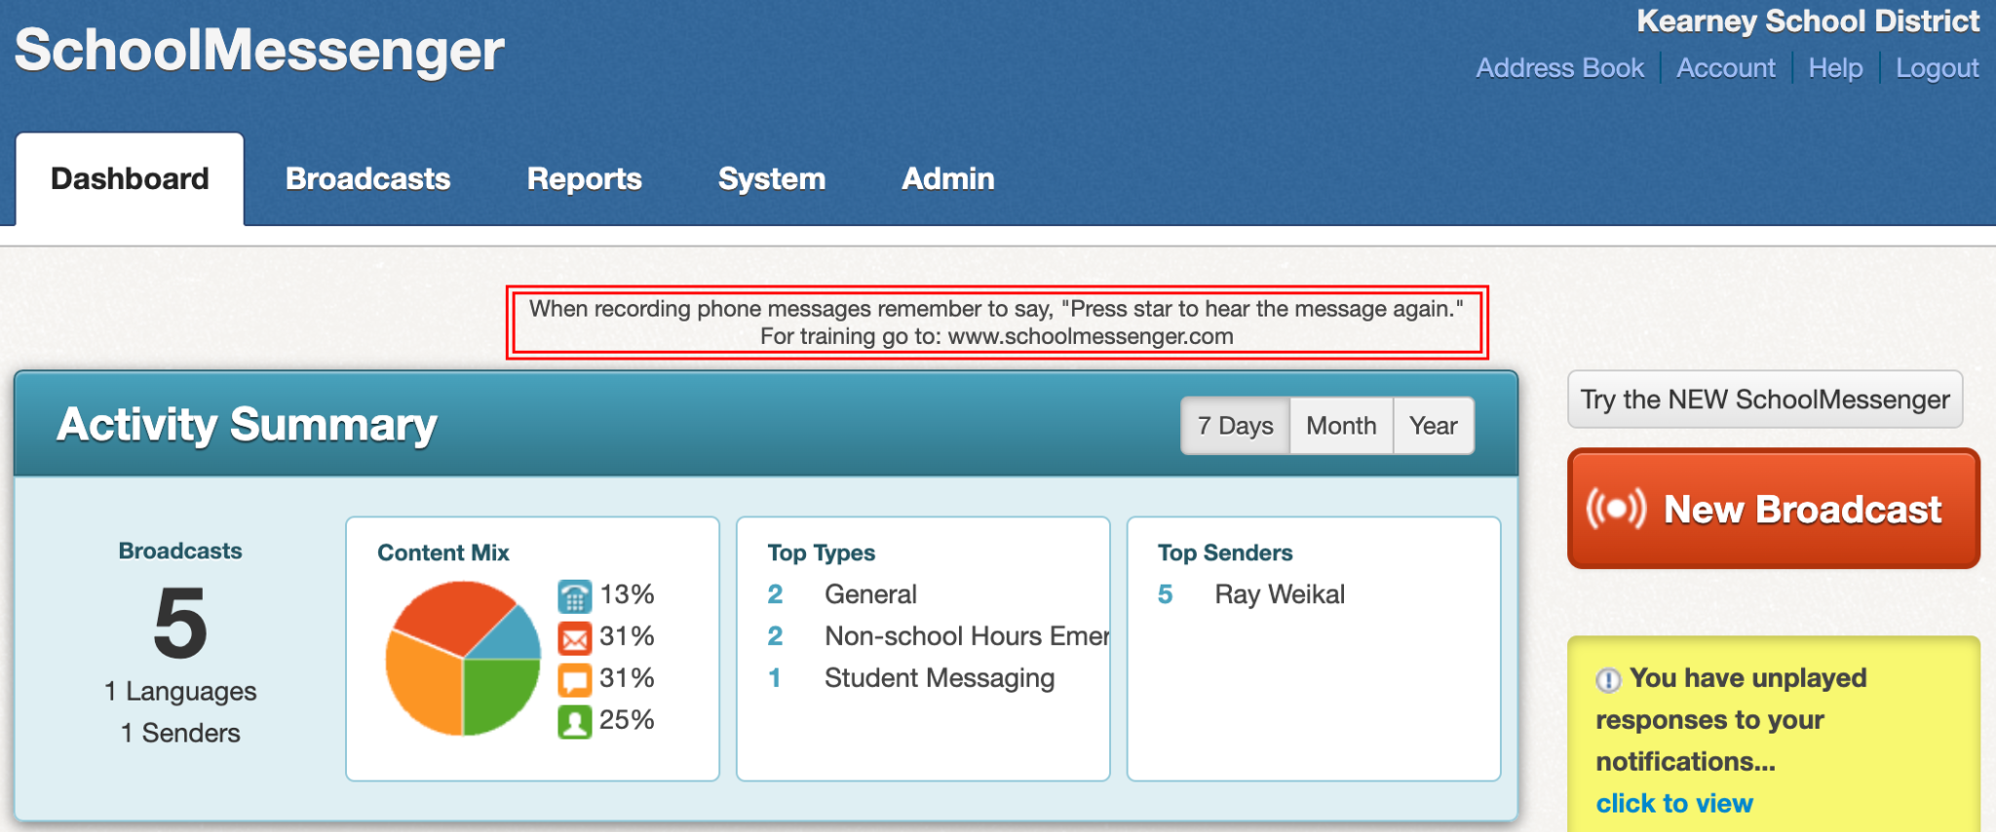
3. Insert “Subject” and select either “Non-school Hours Emergency” or “School Hours Emergency” from the “Type” menu  
   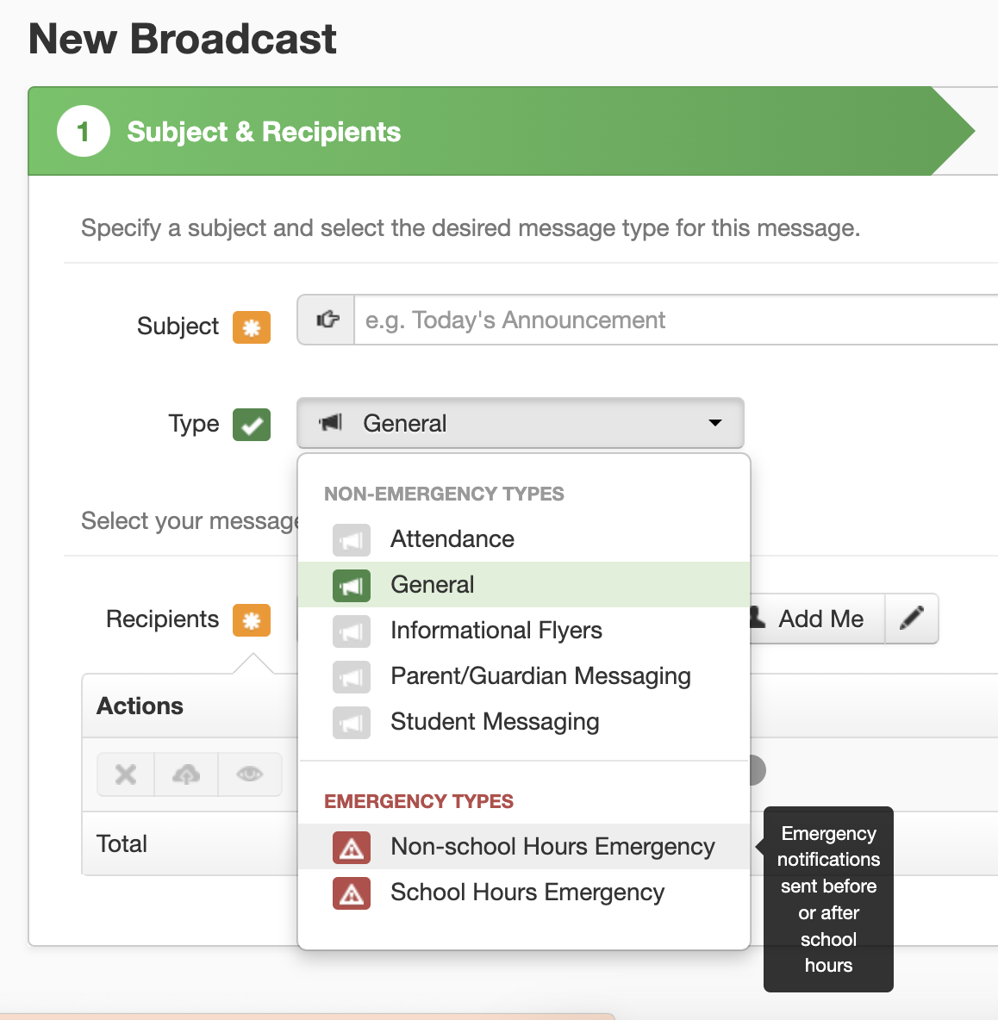
4. From the “Recipients” menu, select “Saved Recipients List”  
   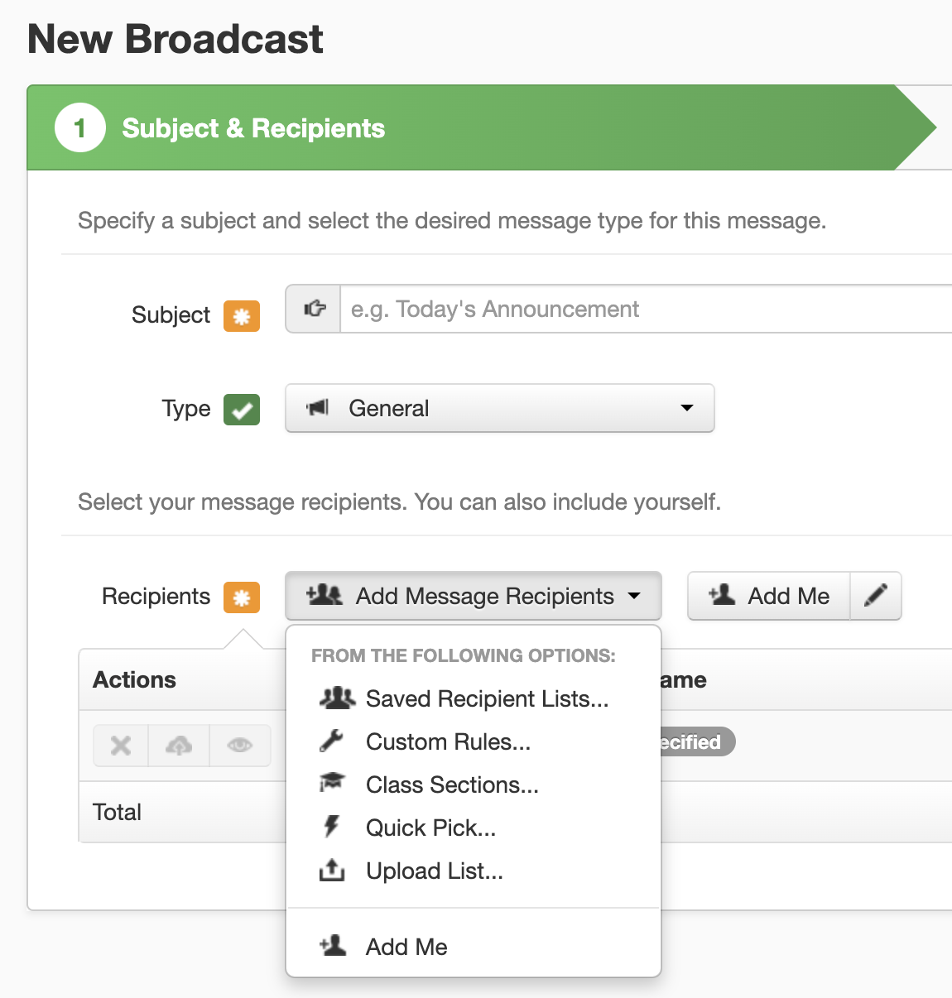
5. Select the appropriate list  
   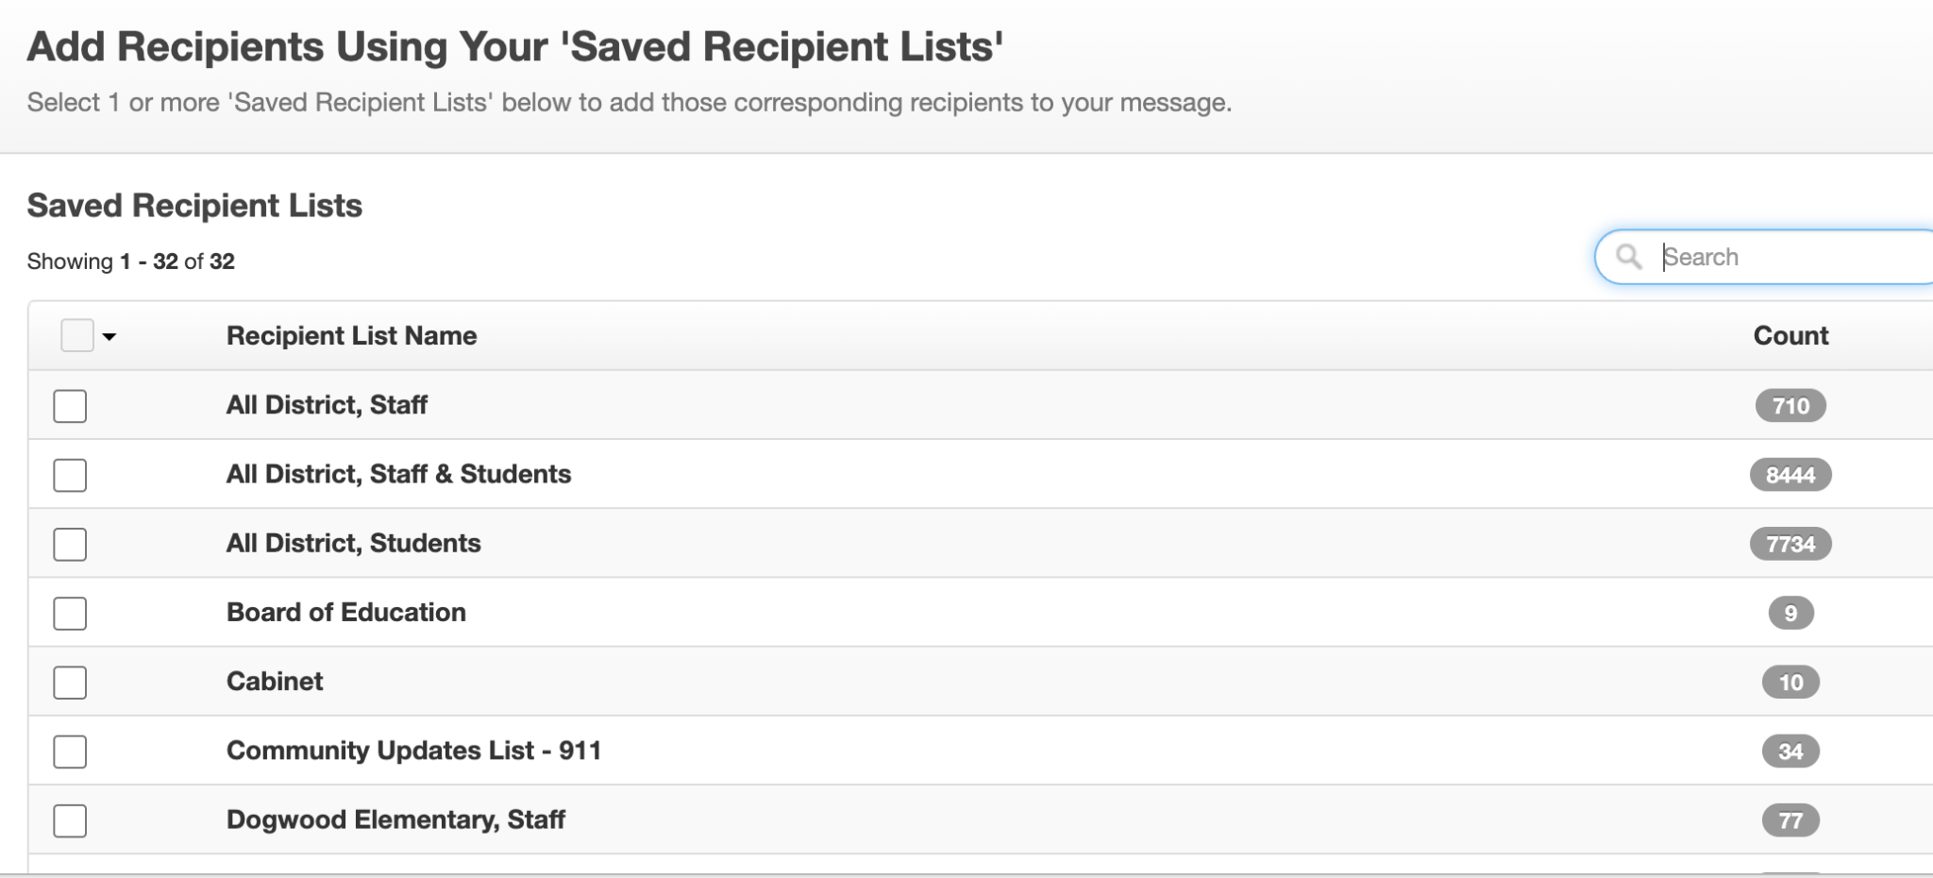
6. Select the media (Robocall, Eblast, Text, Push Notification)  
   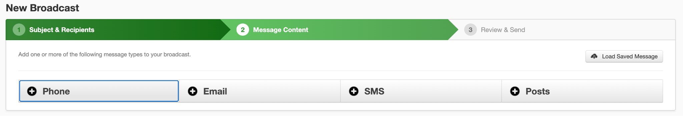

## Create Robocall

1. Click on “Phone.”  
   Use the blank space to paste and edit your message.  
   Insert the appropriate phone number.  
   Press “Call Now to Record,” and follow the instructions to record a robocall.  
   Click “Save” in the bottom-right corner  
   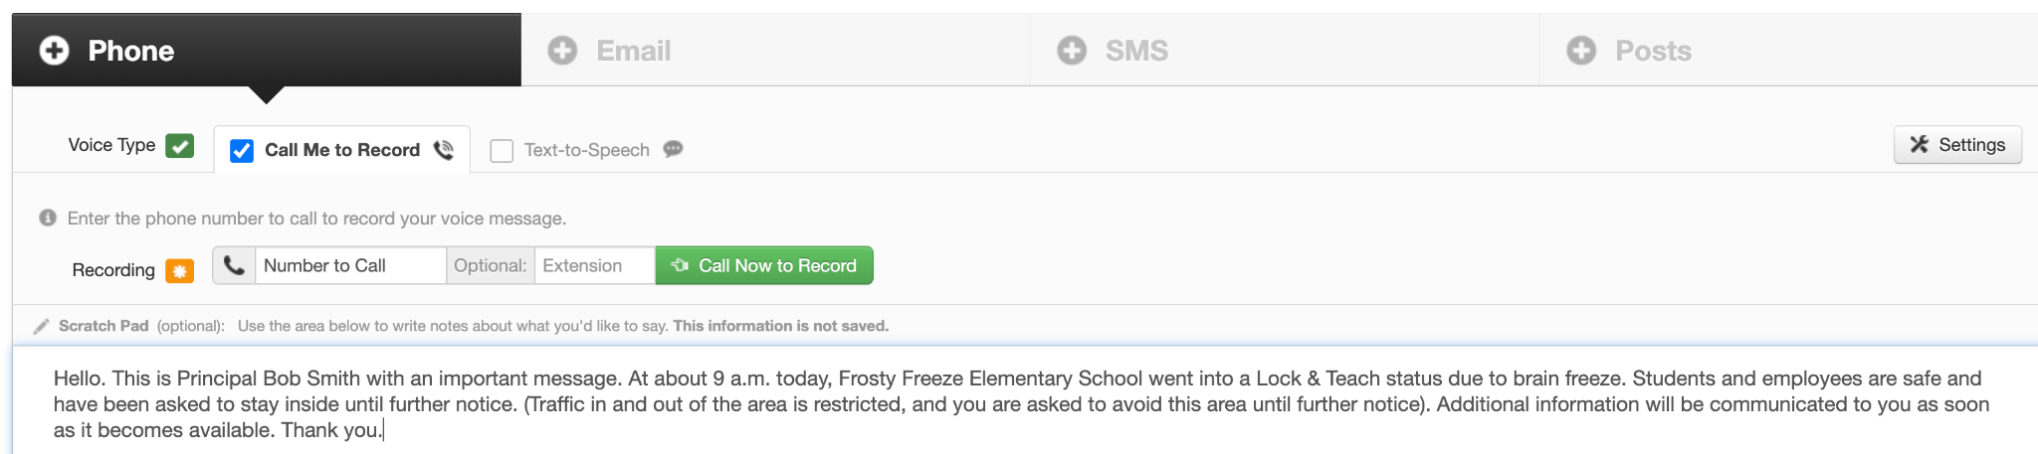

## Create Eblast

1. Click on “Email.”  
   Fill in the “From Email,” “Reply to Email” and “Subject” prompts.  
   Click “Stationary.”  
   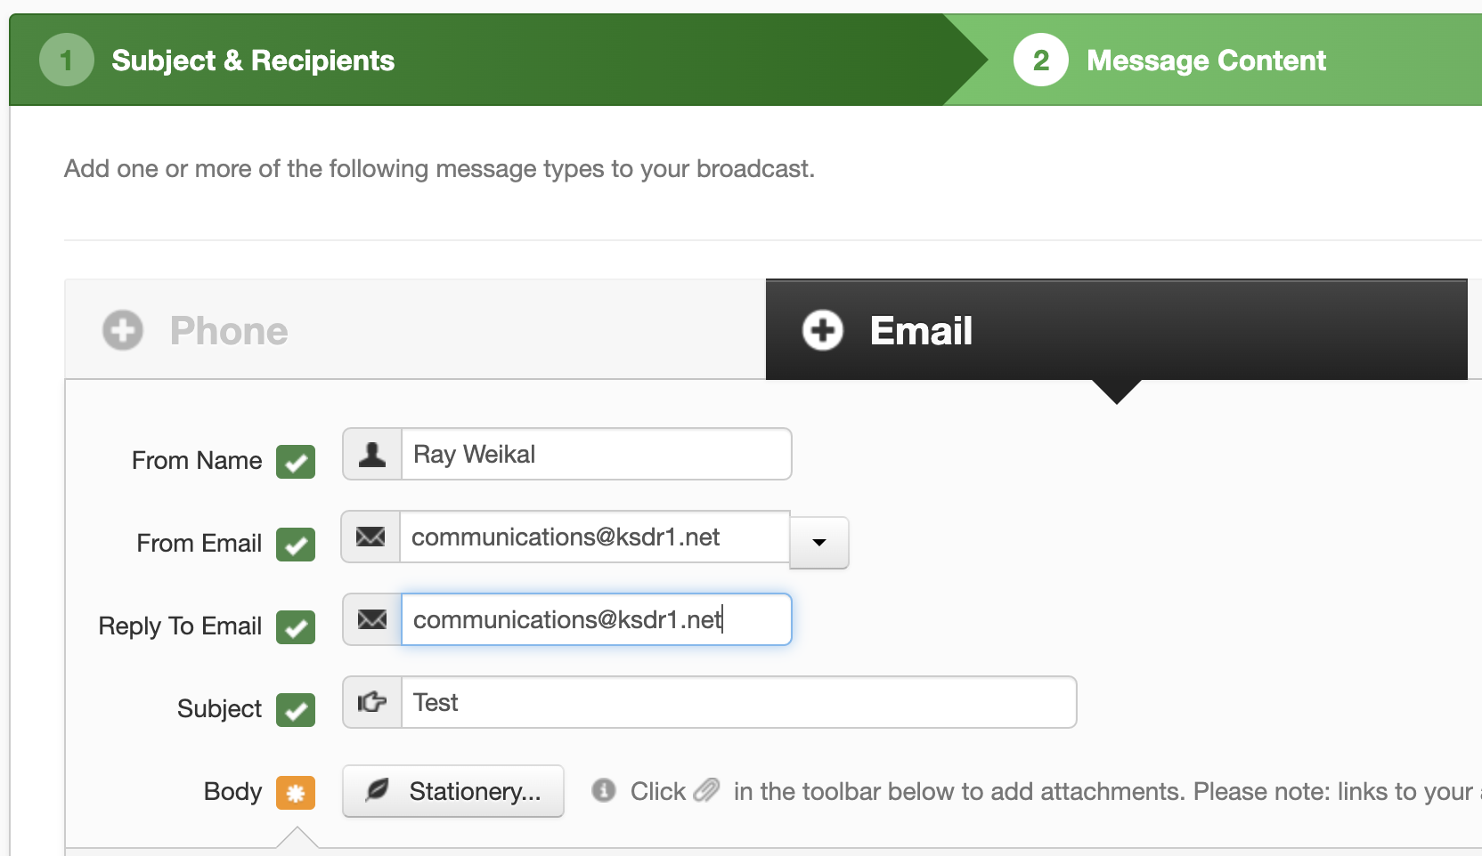
2. Select the appropriate stationery
3. Fill out the message subject line and content
4. Click “Save” in the bottom-right corner

Create Text Message

1. Click “SMS.”  
   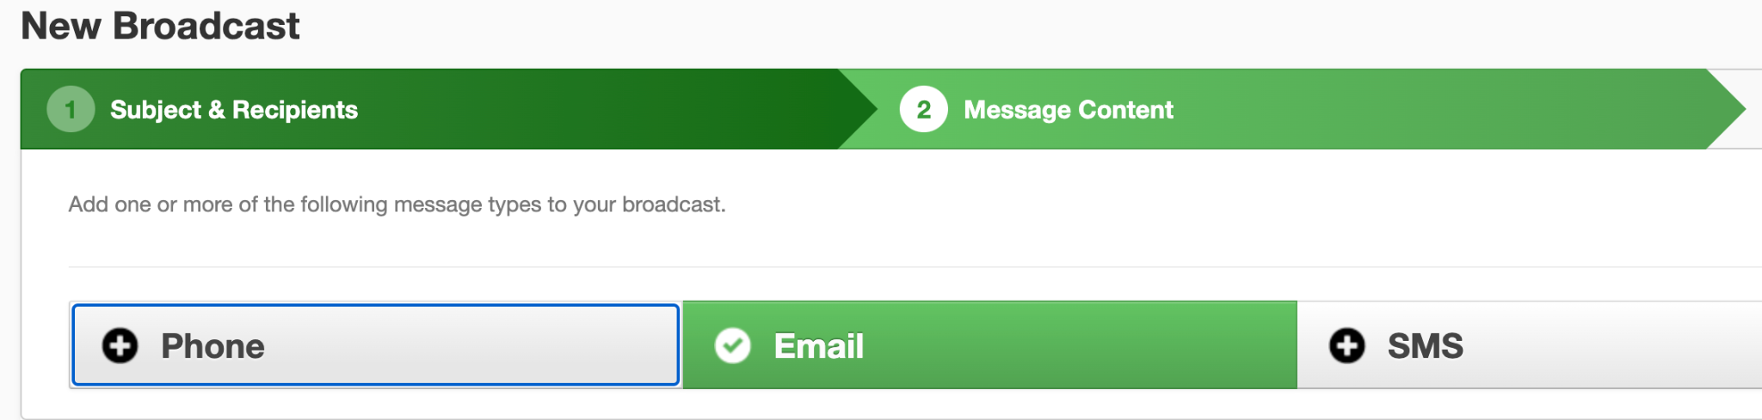
2. Insert the message.  
   Click “Save” in the button-right corner  
   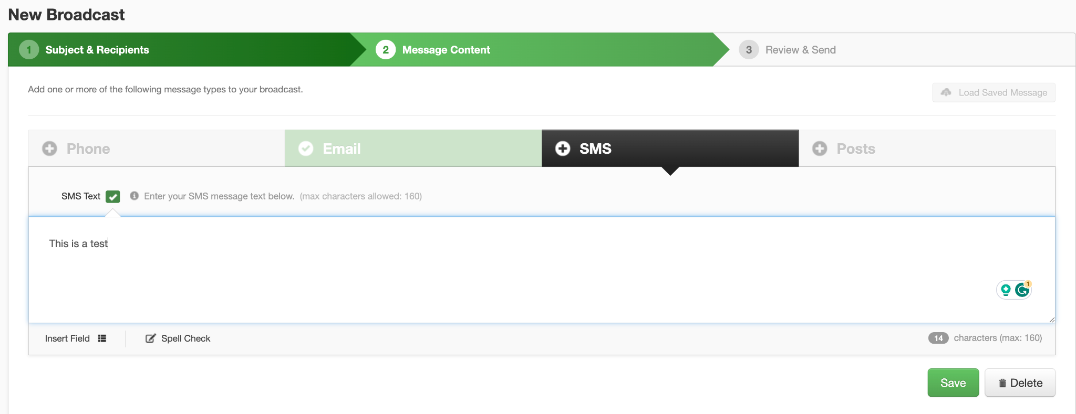

## Create Push Notification

1. Click “Post.”  
   Fill in the message subject and content.  
   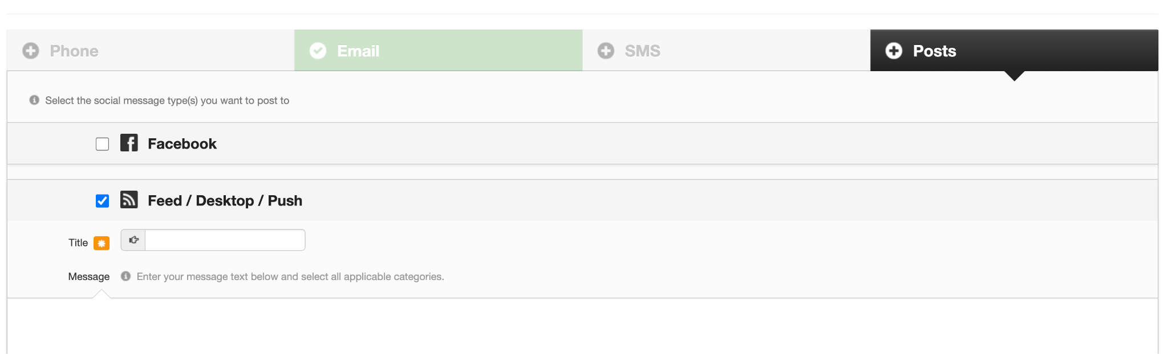
2. Select the appropriate category.  
   Click “Save” in the bottom-right corner.  
   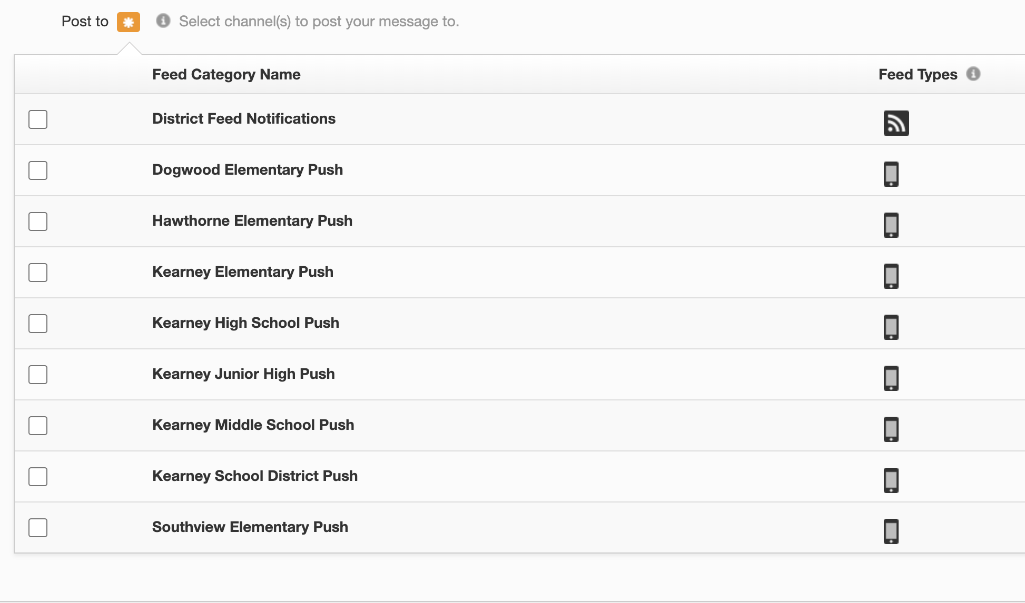

## Send Message

1. Click “Review & Send.”  
   Double-check that the subject, broadcast type, recipient count and message content are all correct.  
   Leave “Email me report of this job upon its completion” and “Skip duplicate email/phone/SMS recipients” as clicked.  
   Click “Save Message Content.”  
   Click “Send Now” or “Schedule to Send Later.”  
   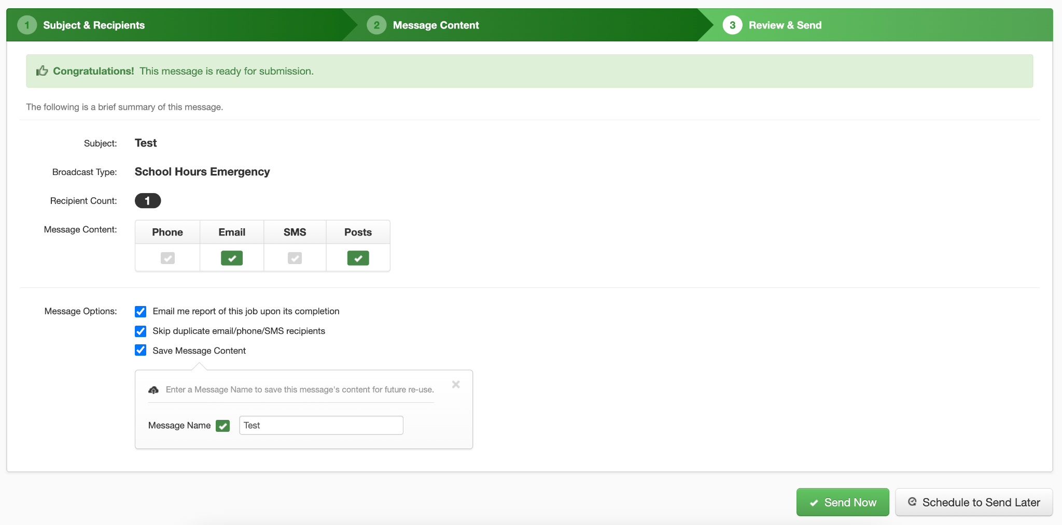

# Media Relations During Emergencies

During an emergency, the media will not be allowed inside the affected school building(s). They are asked to refer any questions/requests to the Director of Communications and Community Relations. We will work to obtain information from our response team and local authorities on site and respond to you as quickly as possible. Please do not try to circumvent this process by contacting the school directly. School phones are needed to manage the situation and they must remain open.

## Public Information Officer

The Director of Communications and Community Relations (Communications Director) will:

* Serve as Public Information Officer (PIO) for communication with the general public and news media
* Coordinate with responding agencies (ex: Kearney Police Department, Kearney Fire & Rescue, Clay County Sheriff’s Office) to determine the appropriate release of information
* Provide updates to credentialed members of the news media (typically a copy of the script/information provided to families)
* Establish a single area or on-site “camp” for media and regulate access to district property
* Facilitate requests for interviews
* Attend any news conferences

The Communications Director and a designated assistant will field phone calls from members of the media and provide basic information (provided by the Incident Commander) to callers.

## News Media Guidance:

* You will be provided a copy of the communication sent to families.
* We are here to protect students, employees, and the educational process from unnecessary turmoil. We will make an administrator available for you to interview. As such we would appreciate it if you would not go to our schools and stop students, families, and employees during dismissal procedures, etc. This is a challenging and sensitive time and we want to be able for them to have as “normal” of a dismissal procedure as possible.
* Additionally, employees have been reminded, “If you have any requests for information from outside the school system, including the media, please direct those individuals to contact the KSD Director of Communications and Community Relations at (816) 628-4112.”
* If this is a high-profile event, challenge the media not to use the perpetrator’s name, but instead focus on the victims. This is a suggestion of the ALERRT (Advanced Law Enforcement Rapid Response Training), and according to their website, “By encouraging the media to focus less on the suspects and more on the victims, it is hoped that future events can be prevented.”

### Script for setting up interviews

* Thank you for your patience, understanding, and sensitivity.
* You will be speaking with (NAME) today, who is a (TITLE). They are a valued member of our Incident Command Staff and have helped to lead our efforts.
* You will be interviewing them at the Kearney School District central office, which is located at 425 W. Washington St. in Kearney, Missouri.
* Please use the main doors on the west side and check in at the front desk.
* You will then be escorted to where you will do the interview.
* You will have (#) of minutes for your interview.
* The subject they will speak with you about is our district/school response, and assisting students, employees, and families.
* Please do not go off the subject above. If you have further questions, please contact the Communications Director.
* As we have an administrator available for you to interview, we would appreciate if you would not go to our schools and stop students, families, and employees during dismissal procedures.
* This is a very difficult and sensitive time, and we want to be able for them to have as “normal” of a dismissal procedure as possible.
* We want to protect them from any unanticipated and unwanted media attention.
* We also want to facilitate providing accurate and appropriate information regarding the incident.
* Here is your interview time (please respond to this email to confirm): (TIME) - (REPORTER NAME)

### Possible Responses to Requests for Further Information

* As per family request, no other information will be released.
* We have a process in place to handle violations of district policies and we will respond accordingly.
* The death did not take place at school. The death was a result of (ACCIDENT/SUICIDE/OTHER REASON). To respect the privacy of the family, that is all the information I have to share.
* We are moving forward from this incident, as it is not representative of (SCHOOL) or its student body.
* It is too early to say what additional steps may be taken to address this incident on a higher level.
* We are taking care of classmates and all students at the schools. We are also caring for grieving teachers, coaches, and employees. Additionally, we are supporting their family members (especially those still in school).
* Response if asked for additional information about conducting drills: Due to the confidential nature of emergency plans, no other information will be provided regarding the drill.
* “We aren’t going on camera but I can send you a statement.”
* “While I can’t comment on this specific issue, here’s a link to our policy manual that states how we address this type of situation.”

### Responses Related to FERPA

We have addressed the incident extensively over the past (NUMBER) of days and appropriate action has been taken. While we understand the desire to know what that action is, it is not directory information and cannot be disclosed in accordance with the Family Educational Rights and Privacy Act (FERPA).

According to the Family Educational Rights and Privacy Act (FERPA), schools are not allowed to share the specifics of an incident if it includes any personally identifiable information about a student or information that a reasonable person in the community can use to identify a specific student.

Disclosing details of a behavior incident and related disciplinary consequences, without the written permission of the respective parent/guardian, is a violation of the student's rights to data privacy under FERPA. Schools are not allowed to share the specifics of an incident if it includes any personally identifiable information about a student or information that a reasonable person in the community can use to identify a specific student.

### Public Info Regarding Lockdowns:

* Date
* School
* Approximate time
* Lockdown or Lock & Teach
* General description (ex: medical issue, law enforcement agency request, student/family issue, etc.).

## Spokesperson Responsibilities

* This individual needs to have the ability to:
  + Acknowledge the event
  + Remain composed
  + Respond with empathy
  + Publicly show support for the prevention and intervention efforts
  + Offer condolences to those affected
  + Focus on victim’s needs
  + Thank everyone who rallied together to provide the support necessary
  + Reiterate who our stakeholders should be listening to
* Share key messages as provided by Communications Director
  + This will help establish credibility.
  + Distribute a copy of the communication to families/news release with information that has been/can be shared.
* Answer questions the general public would want answers to:
  + Who was involved?
  + Who was affected?
  + Who is overseeing the response?
  + Are there any risks for students/families at this time?
  + When did this occur?
  + Where did this occur?
  + Was there forewarning?
  + Why wasn’t this prevented from happening?
  + Can anything else “go wrong?”
  + When will normal operations resume?
  + What (if any) resources are available?
* Be prepared to accept criticism and blame
* Commit to providing additional updates, if needed
  + Be specific about when

# Family Educational Rights and Privacy Act (FERPA) Considerations

According to the Family Educational Rights and Privacy Act (FERPA) and the Disclosure of Student Information Related to Emergencies and Disasters:

FERPA permits school officials to disclose, without consent, education records or personally identifiable information from education records, to appropriate parties in connection with an emergency, if knowledge of that information is necessary to protect the health or safety of the student or other individuals.

Disclosures made under the health or safety emergency provision must be, “in connection with an emergency,” which means to be related to the threat of an actual, impending, or imminent emergency, such as a natural disaster, a terrorist attack, a campus shooting, or the outbreak of an epidemic disease.

Typically, law enforcement officials, public health officials, trained medical personnel, and parents are the types of appropriate parties to whom information may be disclosed under this FERPA exception. In some situations, state and local emergency management agencies who are coordinating a disaster response might be considered appropriate parties if their knowledge of the information is necessary to protect the health or safety of the student or other individuals. Students who are separated from their families may have serious medical needs. A school could disclose information about the student’s medication or special needs to appropriate officials who are seeking to address those needs.

FERPA would generally permit school officials to disclose immunization and other education records to public health authorities under the health or safety emergency provision of FERPA if it is in connection with a health or safety emergency and the knowledge of the information disclosed was necessary to protect the health and safety of the students or other individuals.

This exception to FERPA’s general consent requirement is temporally limited to the period of the emergency and generally does not allow for a blanket release of personally identifiable information from the student’s education records.

When making a disclosure under the health or safety emergency provision in FEPRA, schools are specifically required to record: (1) the articulable and significant threat to the health or safety of a student or other individuals that formed the basis for the disclosure, (2) the parties to whom the school disclosed the information, and (3) maintain the record with the education records of each student as long as the records are maintained.

# Guidelines for Post-Incident Statements

## Appropriate Statements Following an Emergency:

* Use normal tone and voice
* It’s okay to not know the answer - “It is normal to have lots of questions. I don’t have that information, this is what I can share”
* Stick with the facts and be straightforward - do not tell students how they should feel
* In the event of a death, use the words “died, dead, death” rather than “went away”, “passed away” etc.
* “I am so sorry to hear this news. Is there something I can do that would be helpful?”
* “I am so sad to hear about this. I can only imagine what you may be going through.”
* “I heard what happened. I understand it may be difficult to concentrate while you are grieving. Please let me know if you are having difficulty and we can work together to address it.”
* “I am sorry that this happened. Please know that I am here to talk with you.”
* Refer students to crisis team or counselor/social worker if you have concerns

## Inappropriate Statements Following an Emergency:

* Emphasizing a positive perspective/trying to cheer the person up: “I’m sure you will feel better soon.”
* Encouraging them to be strong and hide their feelings: “You don’t want your friends to see you cry.”
* Tell them how they should feel: “You must be sad.”
* Compete for sympathy: “This happened to me when I was your age, too.”

# Cyber Events/Incidents

For communications related to cyber security, an “event” precedes an “incident.” An incident is any one or more of the following:

* Loss of information confidentiality (data theft)
* Compromise of information integrity (damage to data or unauthorized modification).
* Theft of physical IT assets including computers, storage devices, printers, etc.
* Damage to physical IT assets including computers, storage devices, printers, etc.
* Denial of service.
* Misuse of services, information, or assets.
* Infection of systems by unauthorized or hostile software.
* An attempt at unauthorized access.
* Unauthorized changes to organizational hardware, software, or configuration.
* Reports of unusual system behavior.
* Responses to intrusion detection alarms.

# After-Incident Debrief

One of the most important aspects of an emergency event is to debrief with employees following the emergency. It is distressing to be with others who are in distress. According to Dr. David Schonfeld from the National Center for School Crisis and Bereavement, “We know that symptoms of trauma can emerge over time for students and staff members.”

Items to discuss include:

* How did we do?
* What did we learn?
* What do we need to improve upon?
* What were our greatest obstacles in responding?
* What resources do you need?

Any suggestions for improvements should be forwarded to the district’s Director of Operations and Communications Director for discussion and possible implementation.

It is paramount that we reiterate to our administrators and employees they:

* Must have their own personal needs met
* Set healthy boundaries
* Get regular, healthy sleep
* Utilize the “Do Not Disturb” setting on your phone, if needed
* Utilize the Employee Assistance Program (info available via Human Resources)